**Cairo University Faculty of Computers and Artificial Intelligence**



**Software Security**

|  |  |  |
| --- | --- | --- |
| **ID** | **Name** | **Group** |
| 20206034 | Abdelrahman Ahmed Mohamed Mansour | S6 |
| 20206003 | Ahmed Hamdy Hamed Elgohary | S6 |
| 20206065 | Muhammed Ashraf Mohamed | S6 |
| 20206061 | Mohamed Ashraf Abdelazim | S6 |
| 20206117 | Youssef Mohamed Talaat | S6 |

|  |  |  |  |
| --- | --- | --- | --- |
| **ID** | **Name** | **Original Severity** | **After Retest Severity** |
| ID01 | Cross site request forgery (CSRF) in Money Transfer | High | Resolved |
| ID02 | SQL Injection Vulnerability in login.jsp  This is twice injection one in (username) and other in (password) | Critical | Resolved |
| ID03 | Cross-site Scripting (XSS) in Search (serach.jsp) | High | Resolved |
| ID04 | Cross-site Scripting (XSS) in Sending Feedback (feedback.jsp) | High | Resolved |
| ID05 | Access control (IDOR) in List Accounts | High | Resolved |
| ID06 | URL Redirection Attack in Customize Site Language | High | Resolved |
| ID07 | Link Injection Attack in index.jsp | Medium | Resolved |
| ID08 | Link Injection Attack in Search (serach.jsp) | Medium | Resolved |
| ID09 | Link Injection Attack in Sending Feedback (feedback.jsp) | Medium | Resolved |
| ID010 | Link Injection Attack in Customize Site Language | Medium | Resolved |
| ID011 | Link Injection Attack in Search News Articles | Medium | Resolved |
| ID012 | SQL Injection Vulnerability in Show Transactions (Start Date) | Critical | Resolved |
| ID013 | SQL Injection Vulnerability in Show Transactions (End Date) | Critical | Resolved |
| ID014 | Direct Access to Administration Pages | Medium | Resolved |
| ID015 | Information Disclosure in login.jsp | Informational | Resolved |
| ID016 | Cross-site Scripting (XSS) in Search News Articles | High | Resolved |
| ID017 | Cross-site Scripting (XSS) in Customize Site Language This is twice xss one in (content) and other in (lang) | High | Resolved |
| ID018 | Information Disclosure in Show Account | Informational | Resolved |
| ID019 | Server Path Disclosure Pattern in feedback.jsp | Informational | Resolved |
| ID020 | Integer Overflow at account main (Show Account) | High | Resolved |
| ID021 | Integer Overflow in Money Transfer | High | Resolved |

**Finding details**

**Name: ID01: Cross site request forgery (CSRF) in Money Transfer**

Test Severity: High

Test Score:

Retest Severity:

Description: Money Transfer at (https://demo.testfire.net/bank/transfer.jsp) is vulnerable to Cross site request forgery (CSRF).This vulnerability allows an attacker to forge requests on behalf of the authenticated user, leading to unauthorized money transfers.

Impact:

The impact of this vulnerability is severe; successful exploitation leads the attacker to

transfer from user account to any account

Recommendations:

The remediation recommendations are listed below in details:

● Implement CSRF Protestation

**Finding scenarios**

**a. Finding Test Steps:**

ID01

1- Open the following page (https://demo.testfire.net/bank/transfer.jsp)

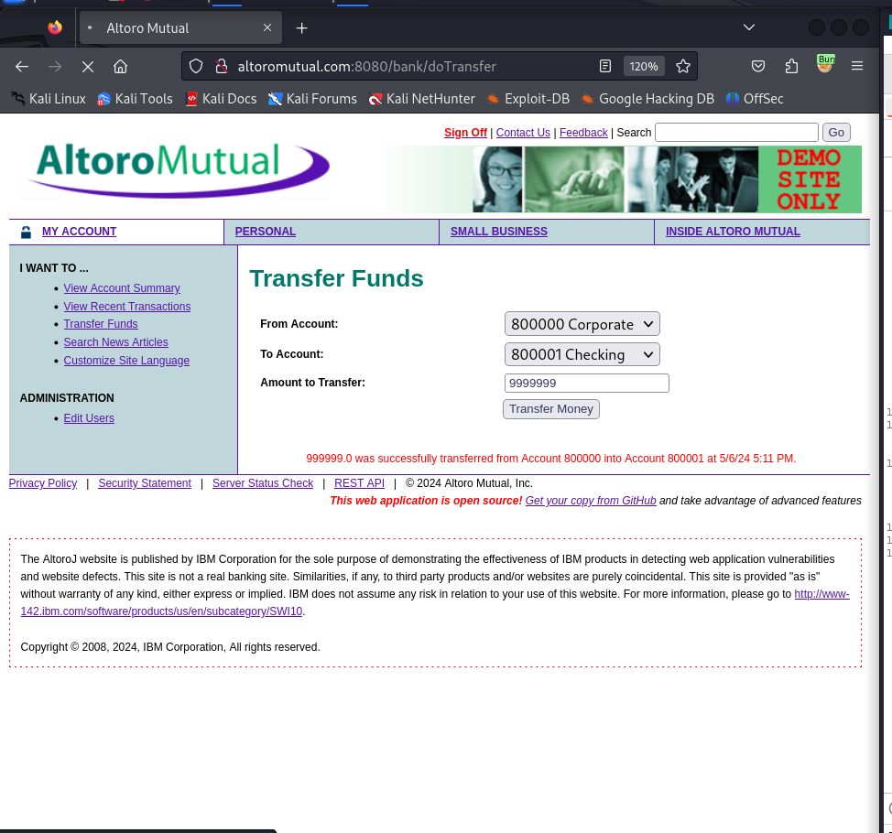

1. Used Burp Suiteto intercept the request

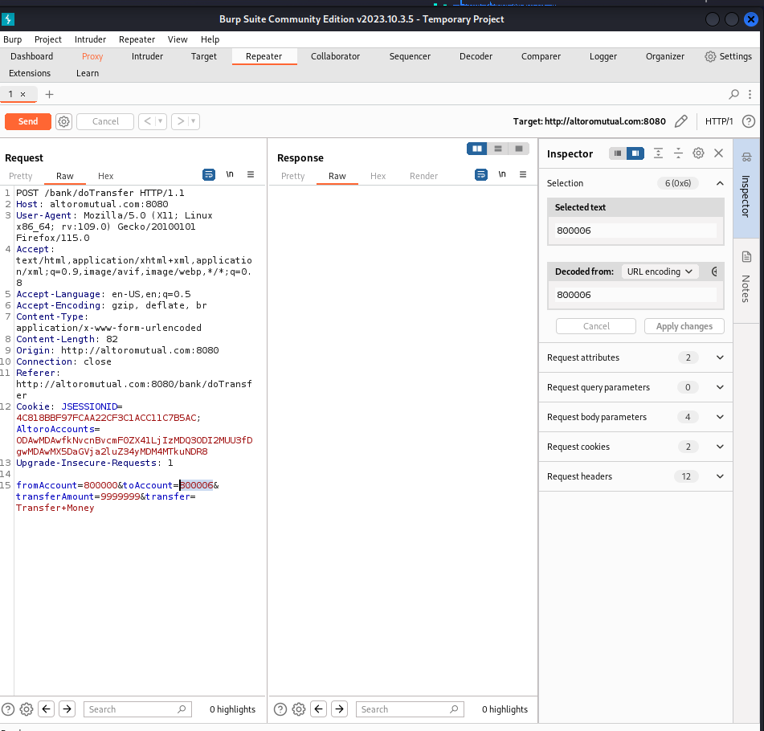

1. Added the following payload change toAccount=8000006 instead of 8000001

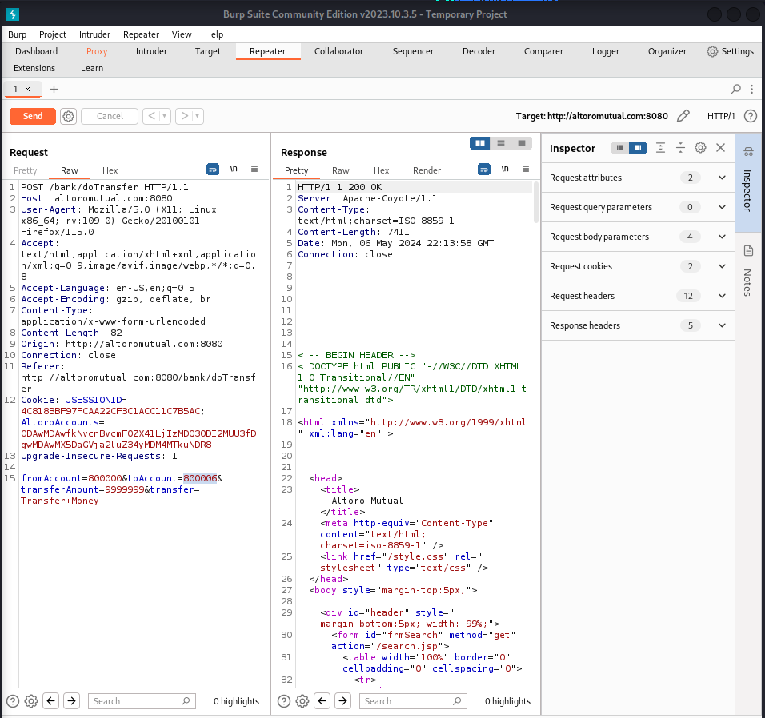

1. The changing of account number done, and therefore, there is Cross site request forgery (CSRF) vulnerability here and the money is sended to other acoount (8000006) succesfully

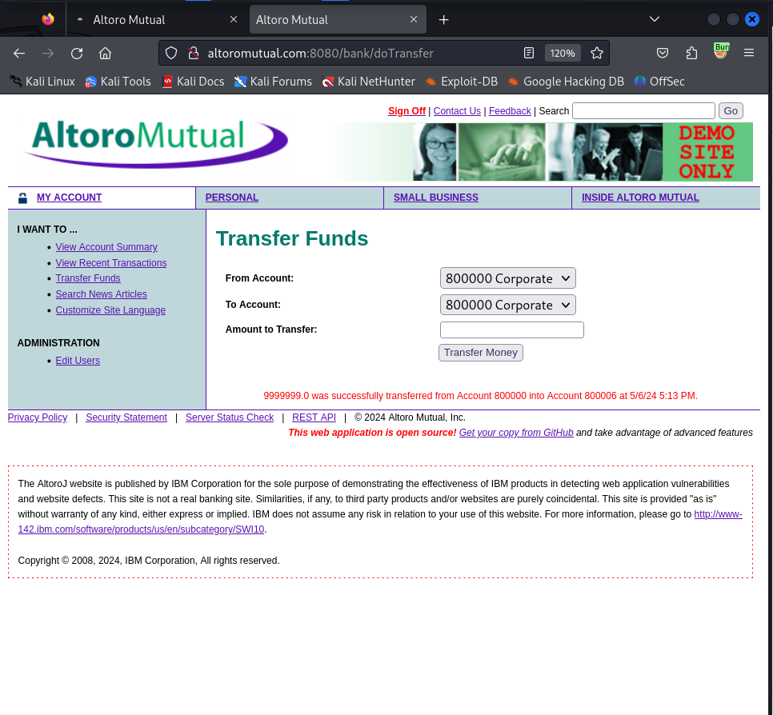

**b. Fixing Steps**

ID01

1- I spot the input in the code

2- I made input validation and/or output encoding as following + screenshot

**c. Finding RE-Test Steps:**

ID01

1- Open the following page (https://demo.testfire.net/bank/transfer.jsp)



2-Used Burp Suiteto intercept the request



3-Added the following payload change toAccount=8000006 instead of 8000001



4- The script has NOT run, and therefore, there is NO XSS vuln here. And the issue

is fixed + screenshot

**Finding details**

**Name: ID02: SQL Injection Vulnerability in login.jsp**

Test Severity: Critical

Test Score: 9.4

Retest Severity: Resolved

Description:

The login page at (https://demo.testfire.net/login.jsp) is vulnerable to SQL injection. By injecting the payload `' OR '1'='1' --` into the username and password fields, an attacker can bypass authentication and gain unauthorized access as admin to the application .

Impact:

Successful exploitation of this vulnerability could lead to unauthorized access to sensitive information, user accounts, or even full compromise of the application.

Recommendations:

1. Implement input validation and parameterized queries to prevent SQL injection attacks.

**Finding scenarios**

**a. Finding Test Steps:**

ID02

1. Open the following page <https://demo.testfire.net/login.jsp>

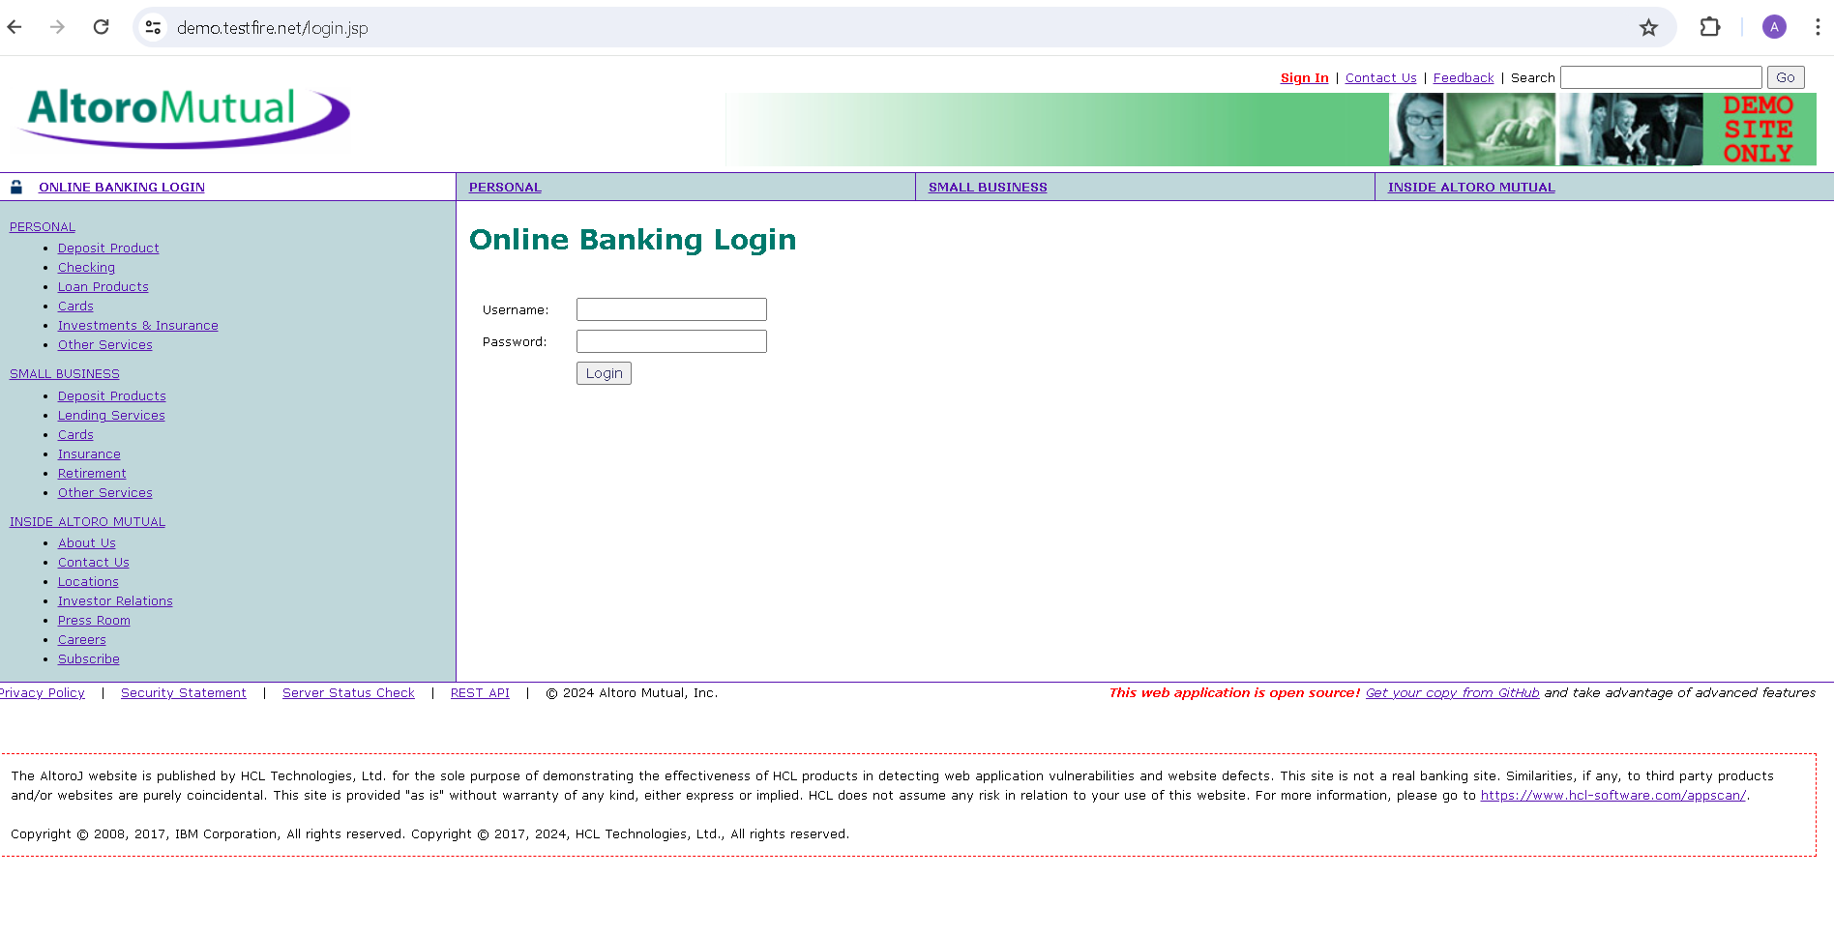

1. Used Burp Suiteto intercept the request

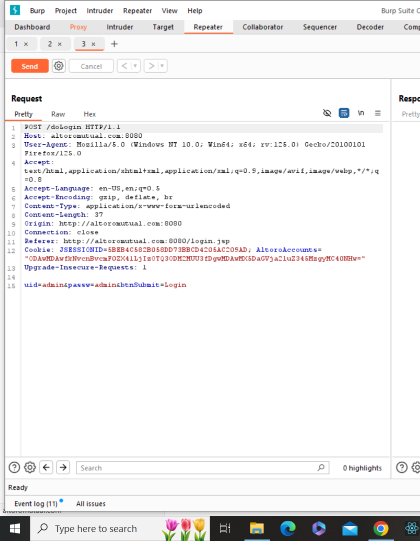

1. Added the following payload (**' OR '1'='1' -- )** in the username and password field  
   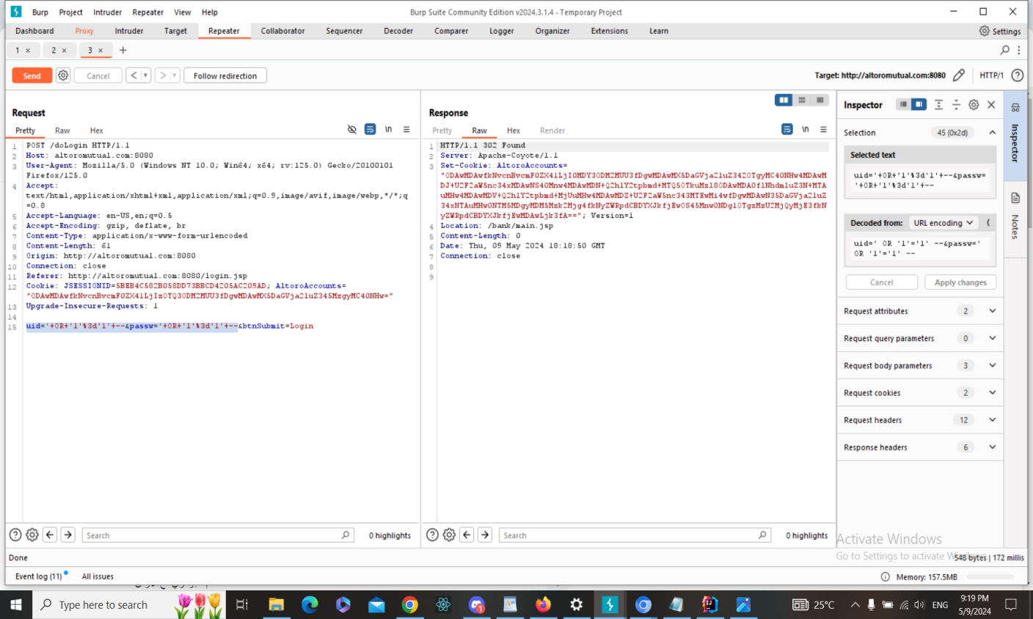
2. The injection has done, and therefore, there is SQL injection vulnerability here and we logged in successfully as admin

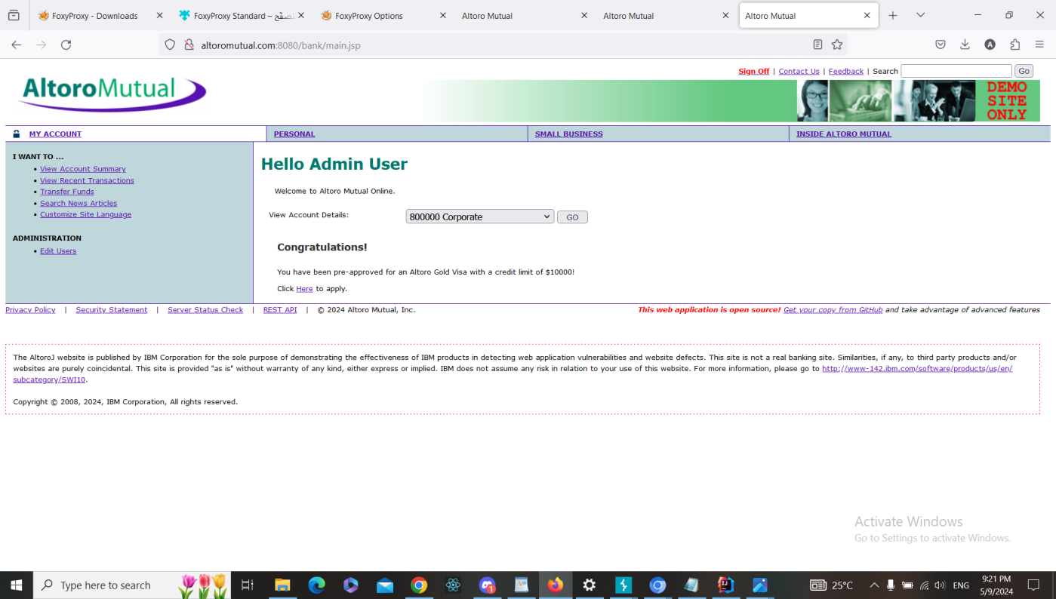

**b. Fixing Steps**

ID02

1. Identified the input in the code, which is the user and password parameters passed to the isValidUser method.

2-Implemented input validation and sanitation by invoking the sanitizeInput method for both the user and password parameters to remove SQL keywords and special characters.

3-Ensured that the sanitized inputs are used in the SQL query to prevent SQL injection vulnerabilities.

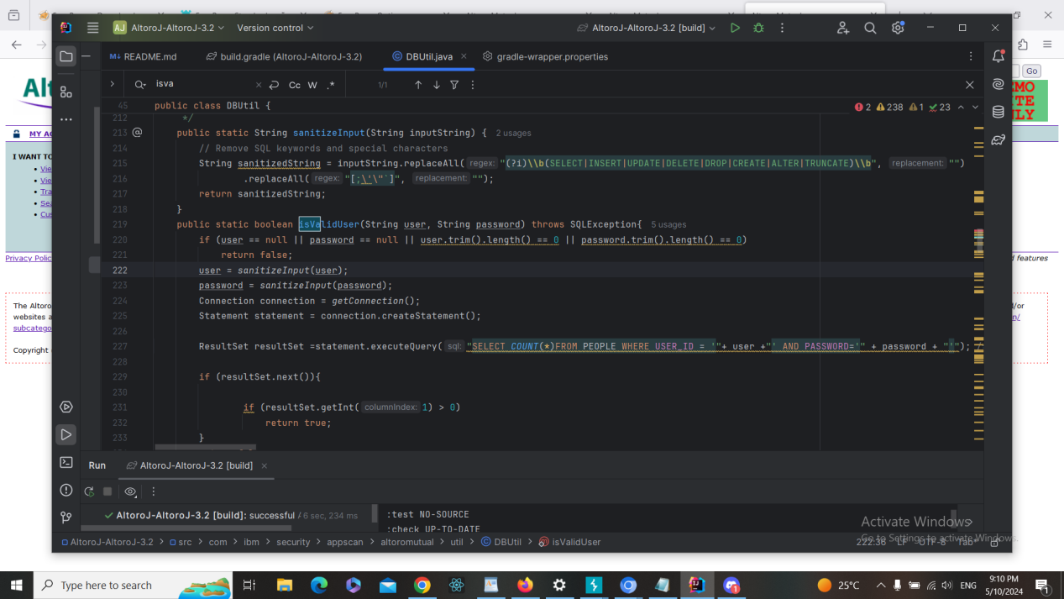

**c. Finding RE-Test Steps:**

ID02

1-Open the following page <https://demo.testfire.net/login.jsp>



2-Used Burp Suiteto intercept the request



3-Added the following payload (**' OR '1'='1' -- )** in the username and password field  
4- The sql injection has NOT run, and therefore, there is NO sql injection vuln here. And the issue

is fixed

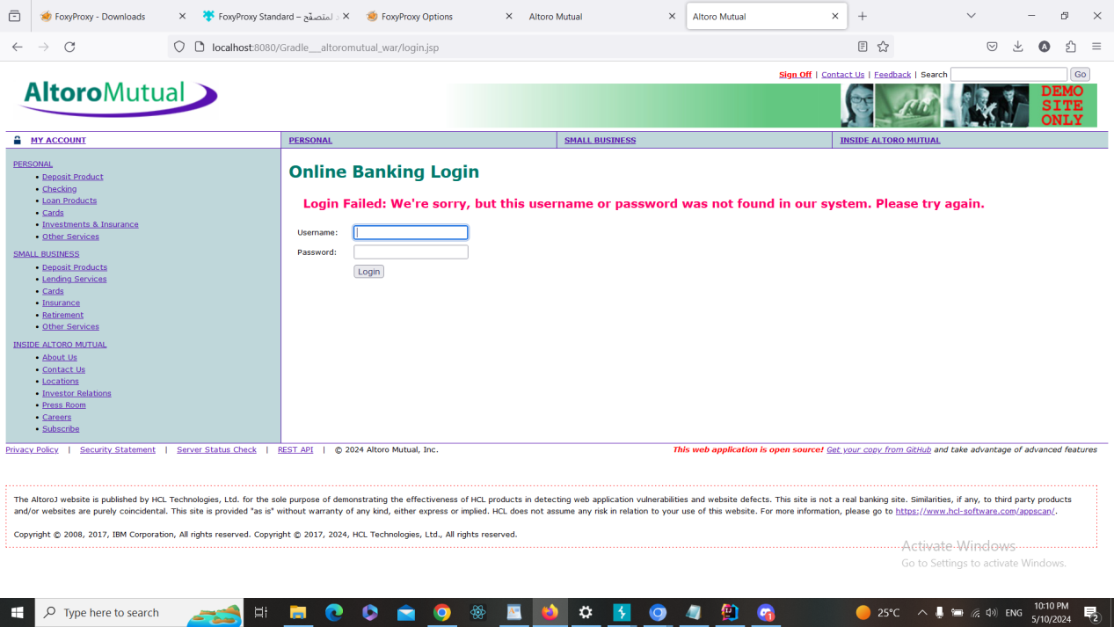

**Finding details**

**Name: ID03: Cross-site Scripting (XSS) Vulnerability in search.jsp**

Test Severity: High

Test Score: 7.3

Retest Severity: Resolved

Description:

The search box at (https://demo.testfire.net) is vulnerable to cross-site scripting. By writing script payload <script>alert(‘hello’)</script> in the search bar , attacker can can execute arbitrary JavaScript code within the context of the user's browser.

Impact:

This vulnerability enables attackers to execute malicious scripts within the victim's browser, potentially leading to various exploits such as session hijacking, phishing, or defacement.

Recommendations:

Implement input validation and output encoding to sanitize user input and prevent the execution of script payloads.

**Finding scenarios**

**a. Finding Test Steps:**

ID03

1. Open the following page <https://demo.testfire.net/index.jsp>

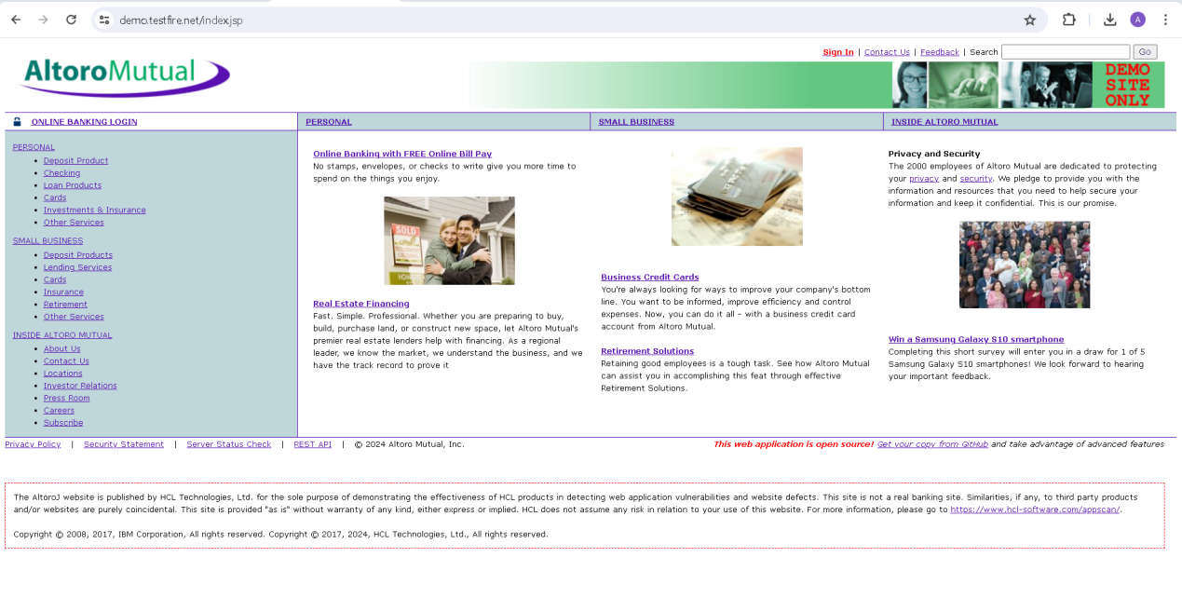

1. Used Burp Suiteto intercept the request

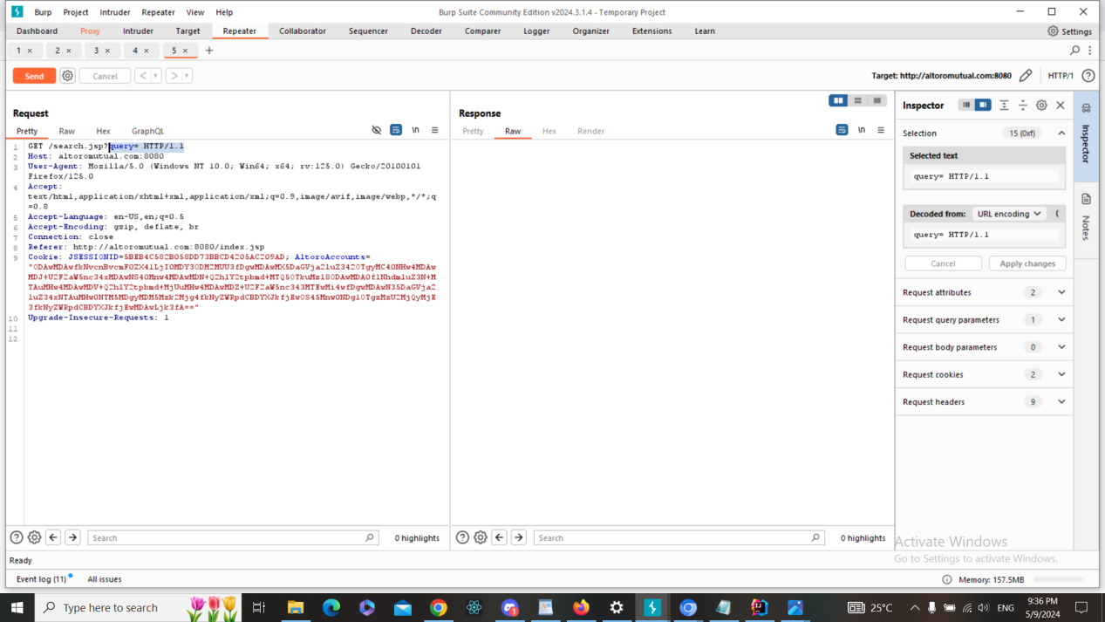

1. Added the following payload <script>alert(‘hello’)</script> in query=

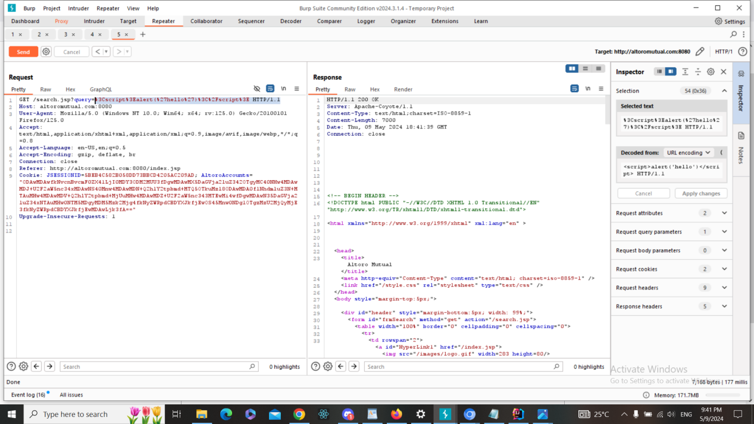

1. The script has run, and therefore, there is XSS vuln here

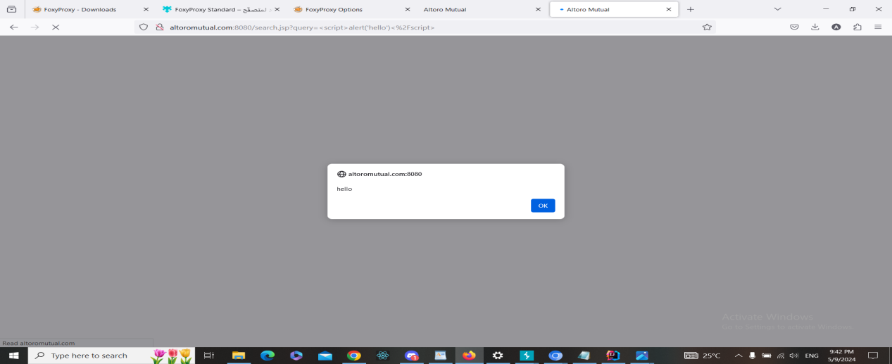

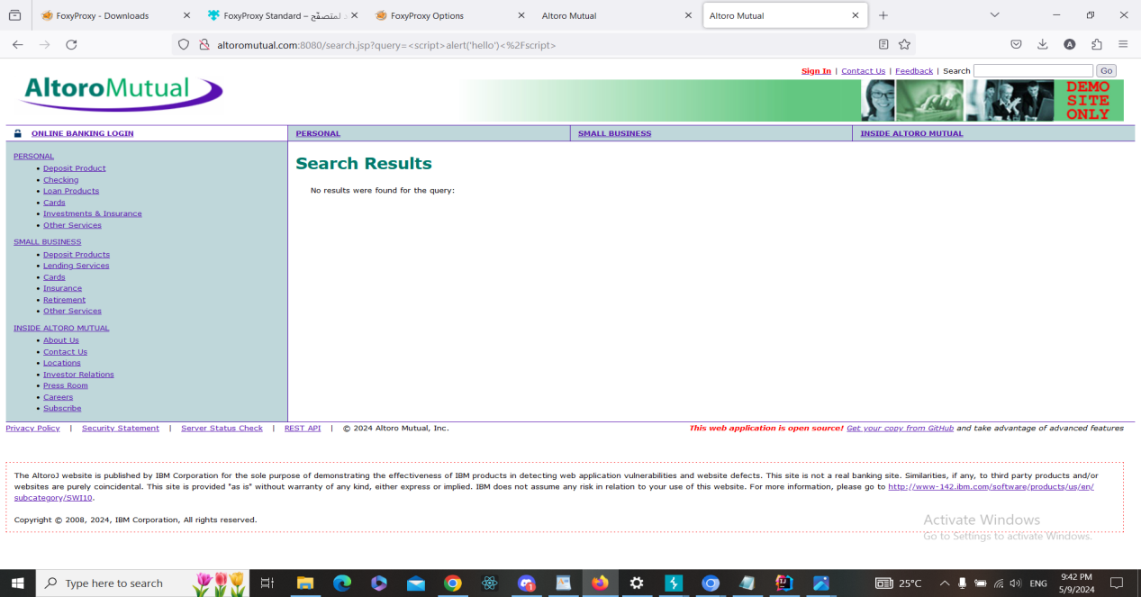

**b. Fixing Steps**

ID03

1- I spot the input in the code

2- I made input validation and/or output encoding as following + screenshot

**c. Finding RE-Test Steps:**

ID03

1-Open the following page <https://demo.testfire.net/index.jsp>



2-Used Burp Suiteto intercept the request



3-Added the following payload <script>alert(‘hello’)</script> in query=



4- The script has NOT run, and therefore, there is NO XSS vuln here. And the issue

is fixed + screenshot

**Finding details**

**Name: ID04: Cross-site Scripting (XSS) Vulnerability in Sending Feedback (feedback.jsp)**

Test Severity: High

Test Score: 7.3

Retest Severity: Resolved

Description:

The Feedback page at (https://demo.testfire.net/feedback.jsp) is vulnerable to cross-site scripting. By writing script payload <script>alert(‘hello’)</script> in the “Your Name” input box, attacker can can execute arbitrary JavaScript code within the context of the user's browser.

Impact:

This vulnerability allows attackers to inject malicious scripts into the Feedback page, potentially leading to various exploits such as session hijacking, phishing, or defacement.

Recommendations:

1. Implement input validation and output encoding to sanitize user input and prevent the execution of script payloads.
2. Utilize security mechanisms such as Content Security Policy (CSP) to mitigate the impact of XSS attacks.

**Finding scenarios**

**a. Finding Test Steps:**

ID04

1. Open the following page <https://demo.testfire.net/feedback.jsp>

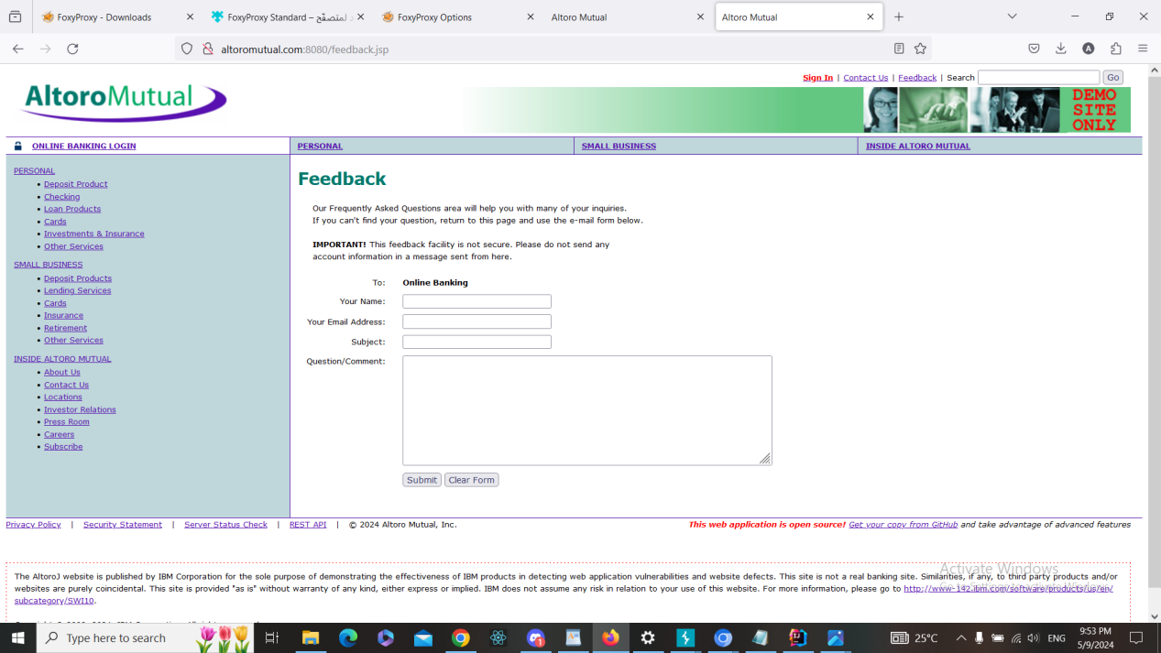

1. Used Burp Suiteto intercept the request

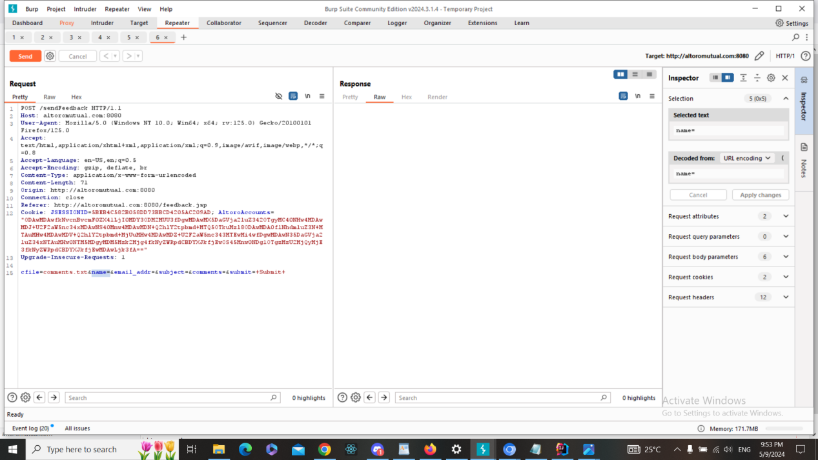

1. Added the following payload <script>alert(‘hello’)</script> in name=

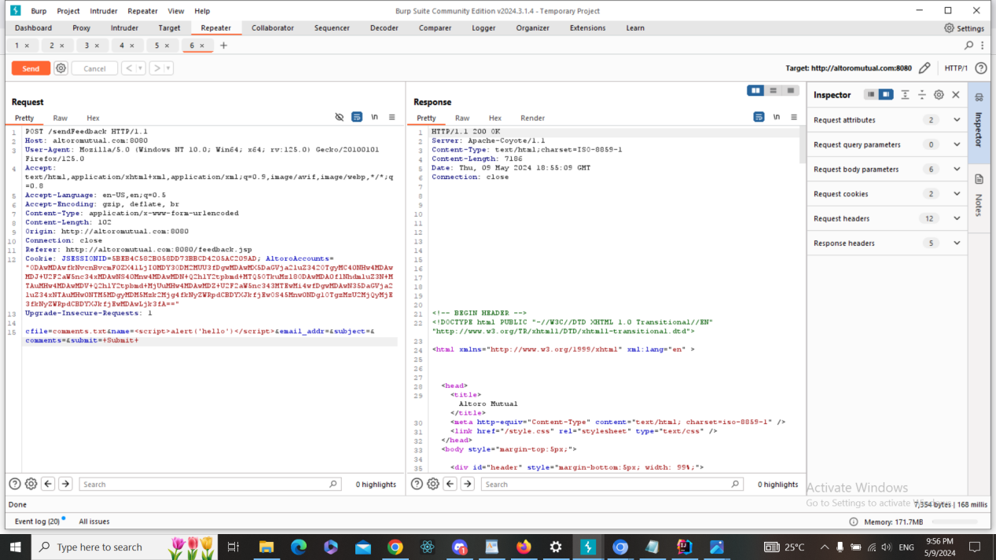

1. The script has run, and therefore, there is XSS vuln here

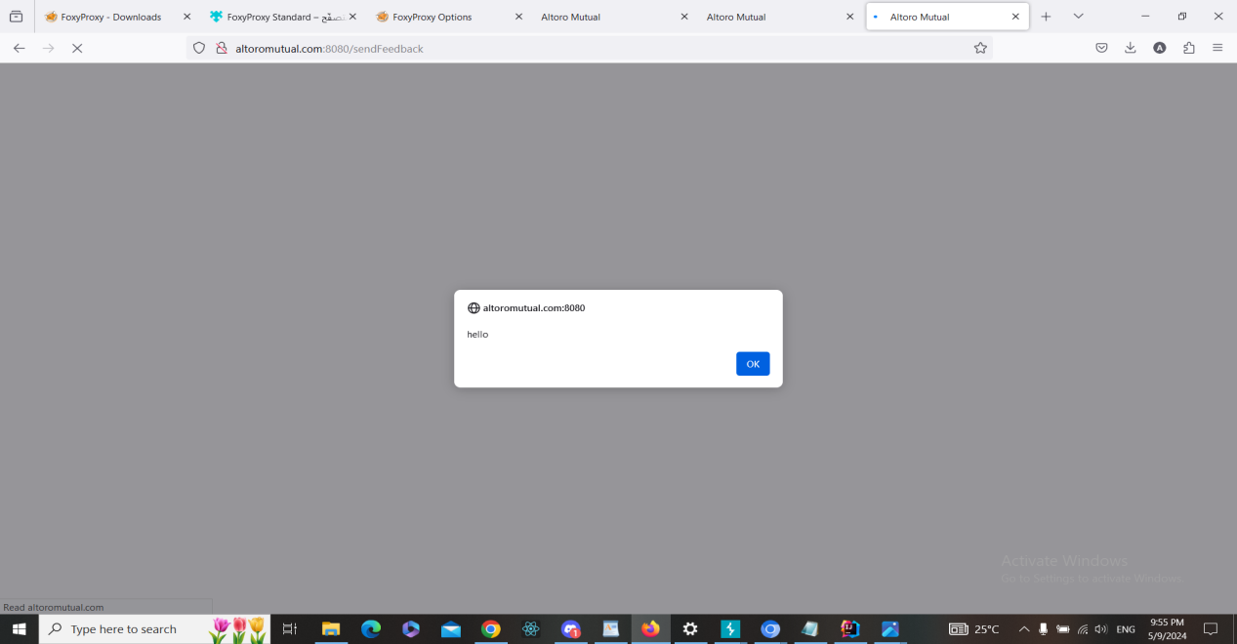

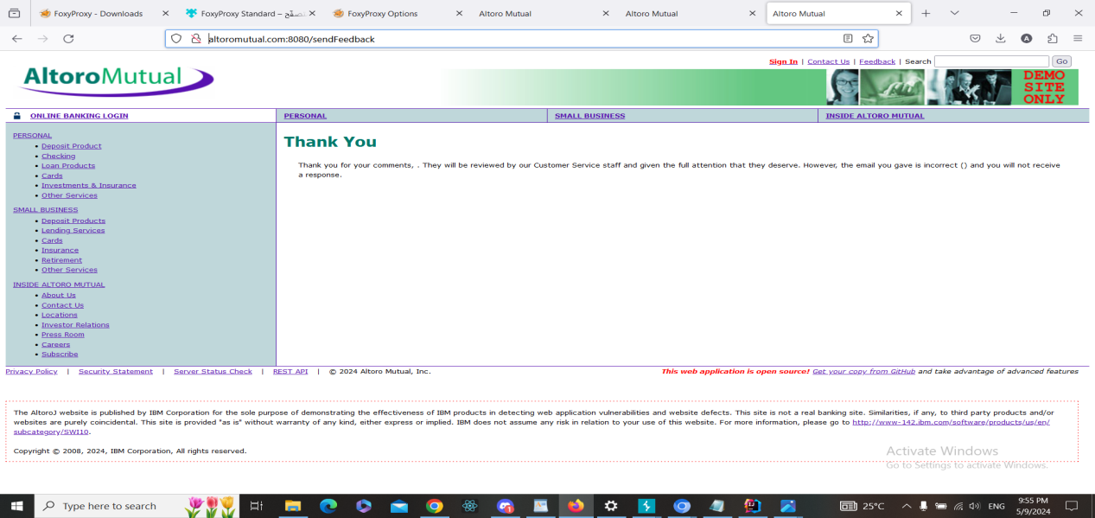

**b. Fixing Steps**

ID04

1- I spot the input in the code

2- I made input validation and/or output encoding as following + screenshot

**c. Finding RE-Test Steps:**

ID04

1-Open the following page <https://demo.testfire.net/feedback.jsp>



2-Used Burp Suiteto intercept the request



3-Added the following payload <script>alert(‘hello’)</script> in name=



4- The script has NOT run, and therefore, there is NO XSS vuln here. And the issue

is fixed + screenshot

**Finding details**

**Name: ID05: Access control (IDOR) in List Accounts** **in List Accounts**

Test Severity: High

Test Score: 7.5

Retest Severity: High

Description: The "List Accounts" functionality at (https://demo.testfire.net/bank/showAccount?listAccounts=800000) is vulnerable to an access control issue known as Insecure Direct Object References (IDOR). This vulnerability allows an attacker to access and manipulate accounts that they are not authorized to view.

Impact:

By exploiting this vulnerability, an attacker can gain unauthorized access to sensitive account information, view other users' account details, and potentially perform unauthorized transactions or actions.

Recommendations:

1. Implement proper access controls and authorization mechanisms to restrict access to sensitive resources based on user privileges.
2. Utilize session-based access controls and enforce authentication checks before allowing users to access account-related functionalities.
3. Regularly audit and review access control configurations to identify and address any misconfigurations or vulnerabilities.
4. Employ techniques such as parameterized queries or object-level permissions to ensure that users can only access their own data and not that of others.

**Finding scenarios**

**a. Finding Test Steps:**

ID05

1. Open the following page

<https://demo.testfire.net/bank/showAccount?listAccounts=800000>

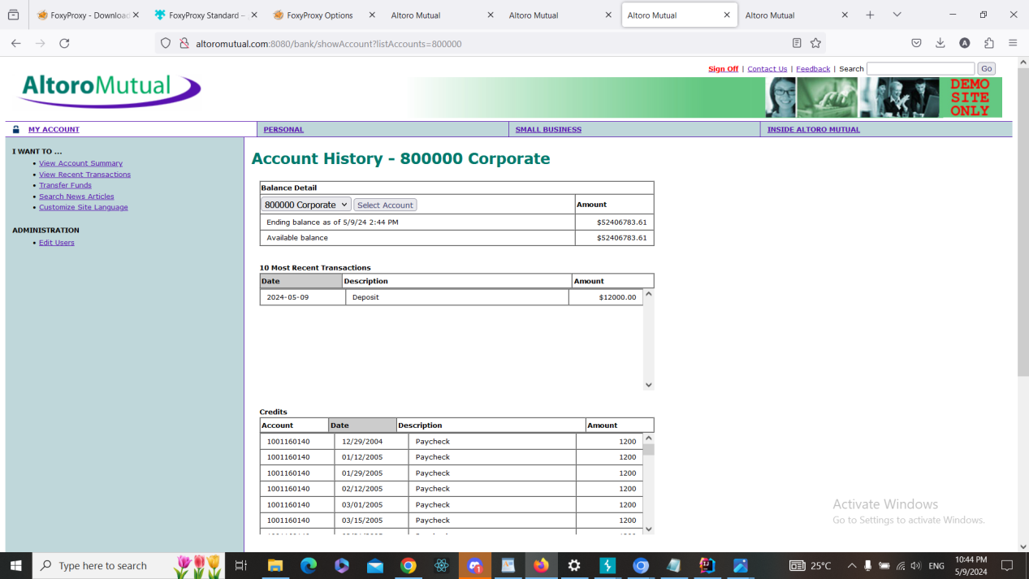

1. Used Burp Suiteto intercept the request

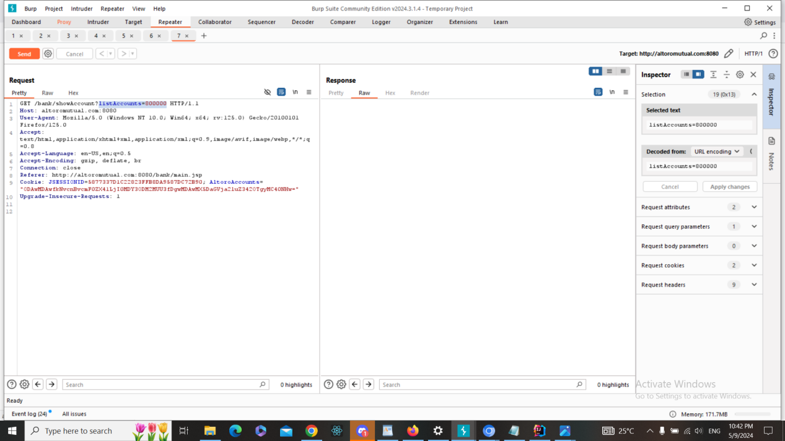

1. Added the following payload (change ListAccounts number to 800003)

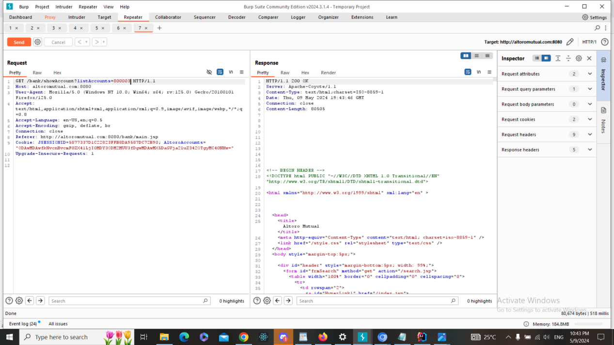

1. The change of account list done , and therefore, there is Access control (IDOR) vuln here in which account 800003 history accessed.

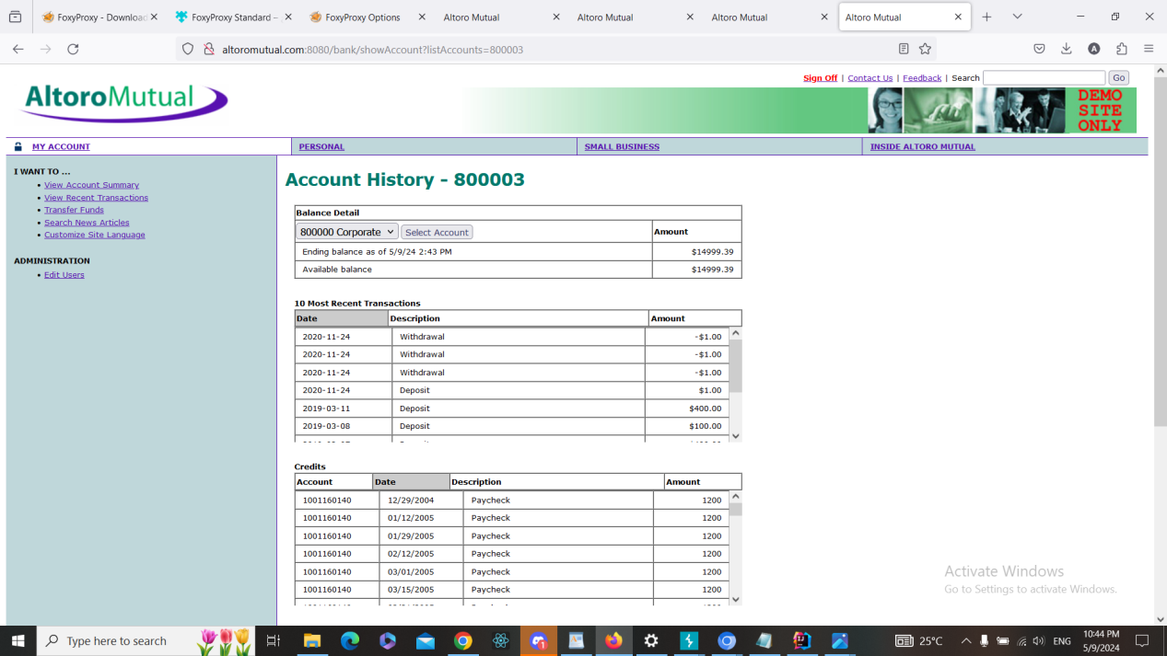

**b. Fixing Steps**

ID05

1- I spot the input in the code

2- I made input validation and/or output encoding as following + screenshot

**c. Finding RE-Test Steps:**

ID05

1-Open the following page

<https://demo.testfire.net/bank/showAccount?listAccounts=800000>



2-Used Burp Suiteto intercept the request



3-Added the following payload (change ListAccounts number to 800003)



4- The script has NOT run, and therefore, there is NO XSS vuln here. And the issue

is fixed + screenshot

**Finding details**

**Name: ID06: URL Redirection Attack in Customize Site Language**

Test Severity: High

Test Score: 8.2

Retest Severity: Resolved

Description:

The Customize Site Language feature on the website (https://demo.testfire.net/bank/customize.jsp) is vulnerable to a URL redirection attack. This vulnerability occurs when user input is not properly validated before being used to redirect users to another page. Attackers can exploit this by crafting malicious URLs that redirect users to phishing websites or malicious content.

Impact:

Users may be tricked into visiting malicious websites, leading to phishing attacks or the installation of malware.

It can damage the reputation and trustworthiness of the website among its users.

Recommendations:

1. Implement proper input validation and sanitization techniques to ensure that user-provided URLs are safe and do not contain malicious redirects.
2. Use a whitelist approach to validate user input, allowing only trusted domains or URLs to be used for redirection.
3. Avoid directly redirecting users based on untrusted input. Instead, provide a confirmation page or use indirect methods of redirection.
4. Educate users about the risks associated with clicking on unfamiliar or suspicious links.

5-Regularly monitor and review the website for any signs of unauthorized redirection attempts.

**Finding scenarios**

**a. Finding Test Steps:**

ID06

1. Open the following page

https://demo.testfire.net/bank/customize.jsp

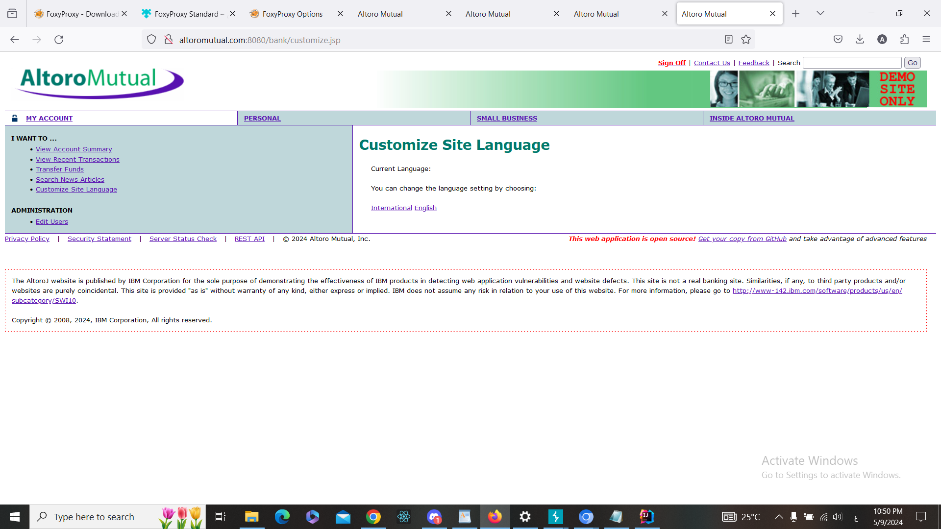

1. Used Burp Suite to intercept the request

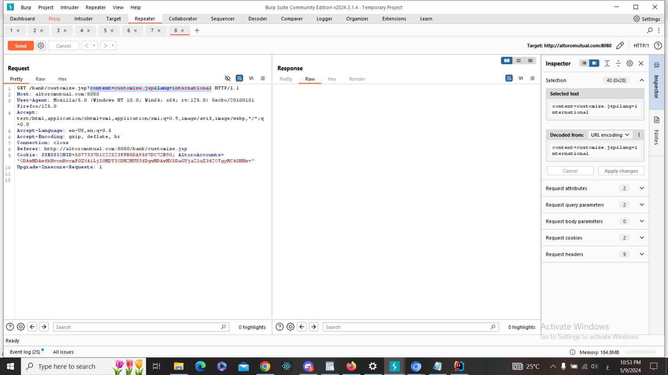

3-Added the following payload  
?content=https://www.google.com&lang=international%20http/1.1 HTTP/1.1

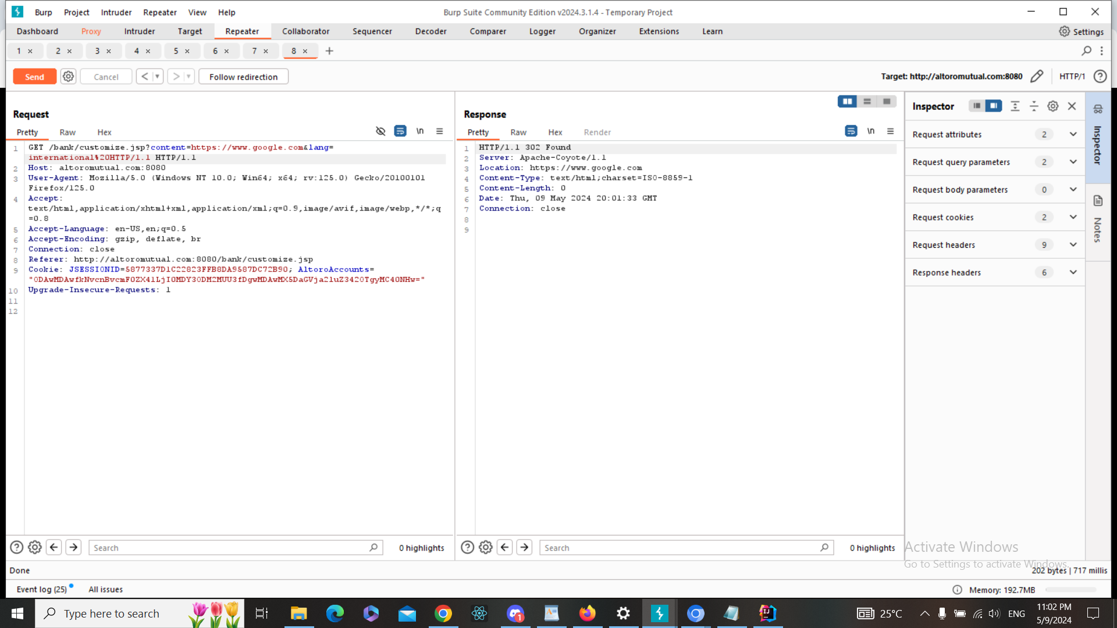

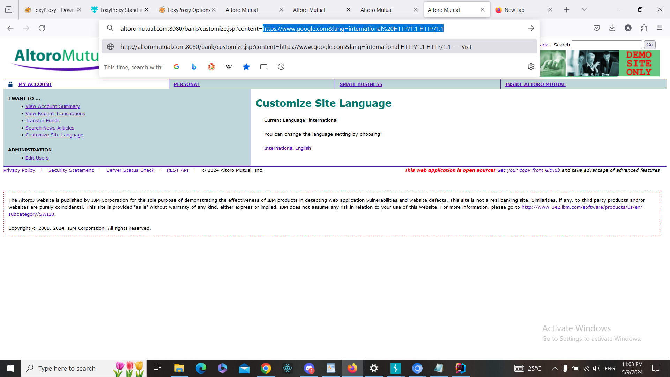

4-The redirection has occurred successfully, and therefore, there is url redirection vuln here

(the redirection was to google.com)

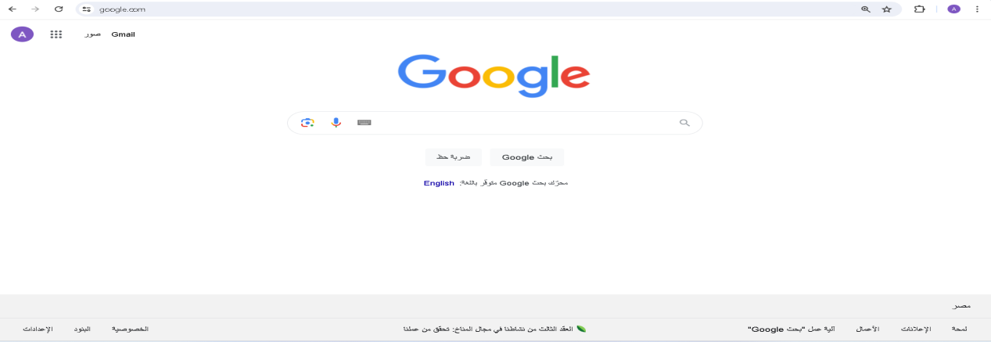

**b. Fixing Steps**

ID06

1- I spot the input in the code

2- I made input validation and/or output encoding as following + screenshot

**c. Finding RE-Test Steps:**

ID06

1-Open the following page

https://demo.testfire.net/bank/customize.jsp



2-Used Burp Suite to intercept the request



3-Added the following payload  
?content=https://www.google.com&lang=international%20http/1.1 HTTP/1.1





4- The script has NOT run, and therefore, there is NO XSS vuln here. And the issue

is fixed + screenshot

**Finding details**

**Name: ID07: Link Injection Attack in index.jsp**

Test Severity: Medium

Test Score: 6.5

Retest Severity: Resolved

Description:

The index.jsp page on the website (https://demo.testfire.net/index.jsp) is vulnerable to a link injection attack. This vulnerability arises when user-supplied input is not properly validated or sanitized before being included as part of a hyperlink. Attackers can exploit this vulnerability to inject malicious links into the page, potentially leading users to phishing websites, malware downloads, or other malicious content.

Impact:

Users may be directed to malicious websites without their knowledge or consent.

Malicious links injected into the page can lead to phishing attacks, where users unwittingly provide sensitive information.

It can damage the trustworthiness and reputation of the website among its users.

Recommendations:

Implement strict input validation and sanitization mechanisms to ensure that user-provided input is safe and does not contain malicious links.

Use proper encoding techniques, such as HTML escaping, to render user input safely within HTML content.

Regularly monitor and review the website's codebase for any signs of vulnerabilities, especially in areas where user input is utilized.

Educate users about the risks associated with clicking on unfamiliar or suspicious links and encourage them to exercise caution while browsing the website.

**Finding scenarios**

**a. Finding Test Steps:**

ID07

1. Open the following page <https://demo.testfire.net/index.jsp>

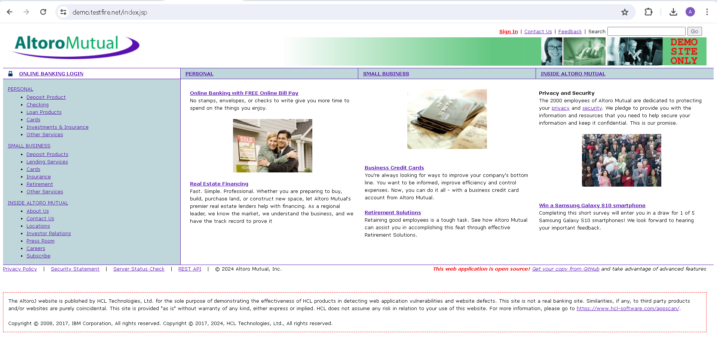

1. Used Burp Suite to intercept the request

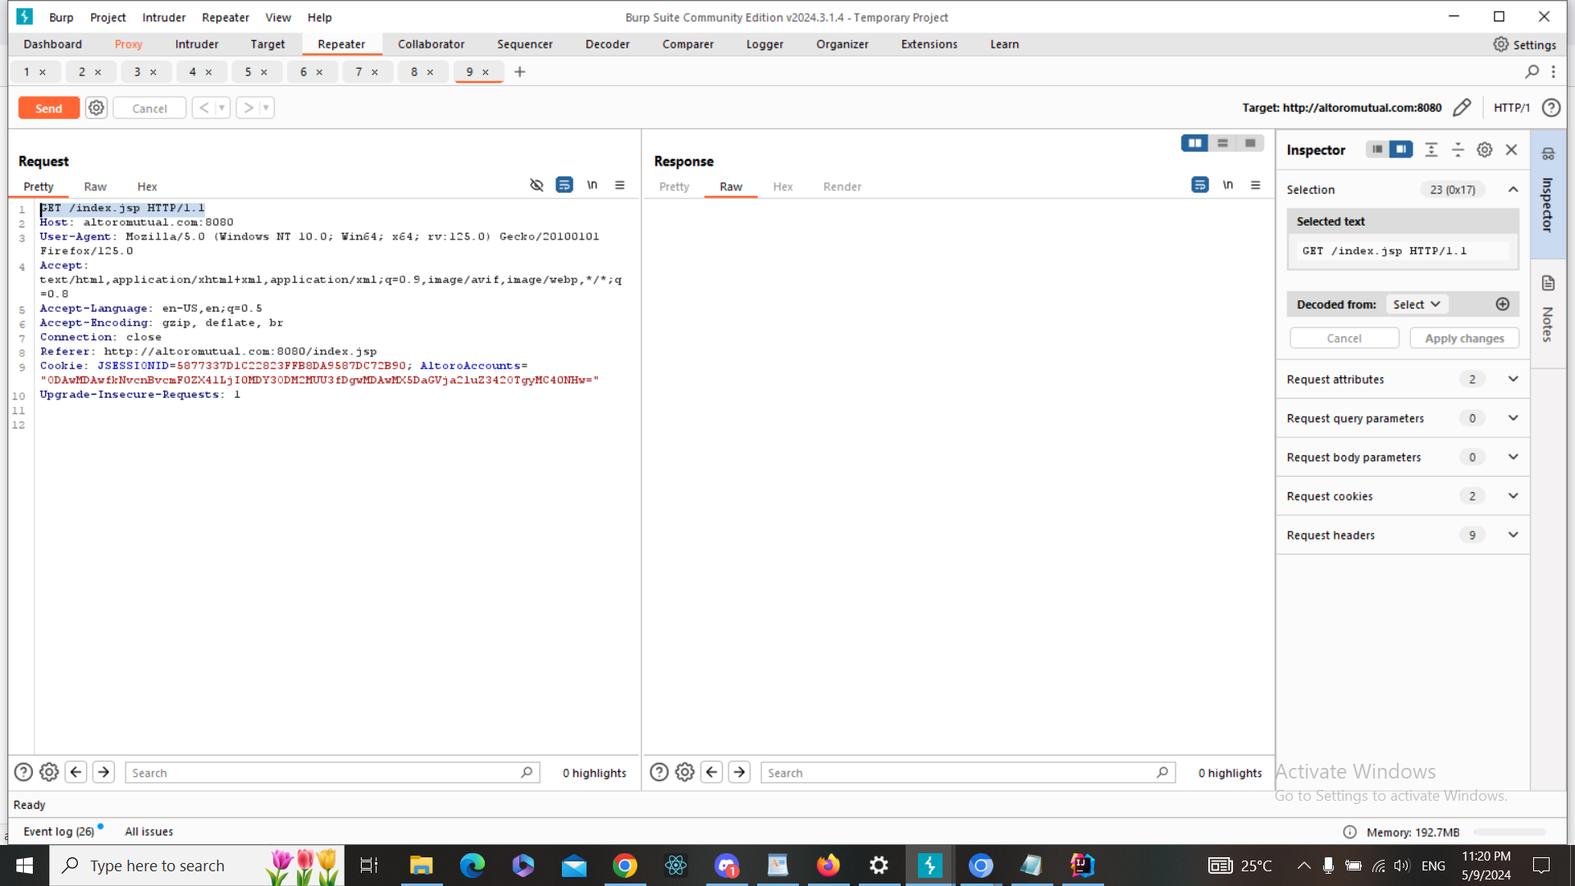

1. Added the following payload

?content="'><A HREF="/WF_XSRF252.html">Injected Link</A> HTTP/1.1

Or encoded payload

%3Fcontent%3D%22%27%3E%3CA%20HREF%3D%22%2FWF_XSRF252.html%22%3EInjected%0ALink%3C%2FA%3E%20HTTP%2F1.1%0A

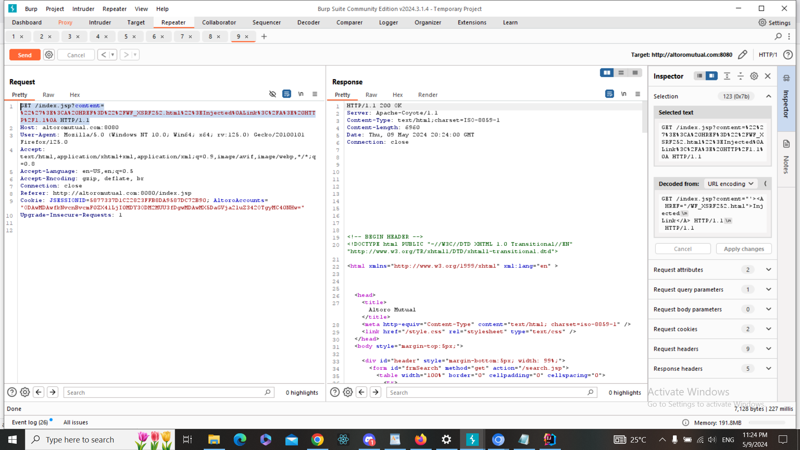

1. The injected link has successfully been added to the page , and therefore, there is Link Injection vuln here

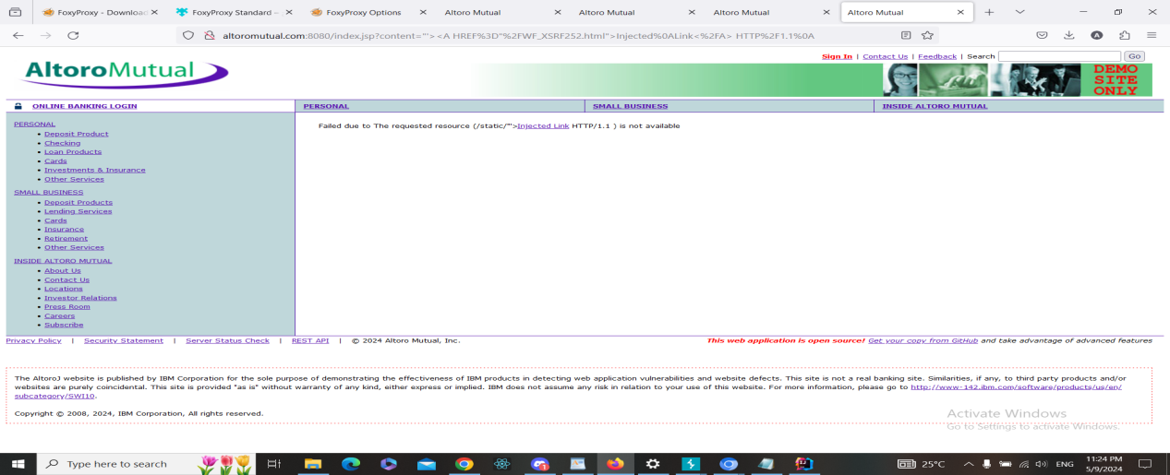

After clicking on the link

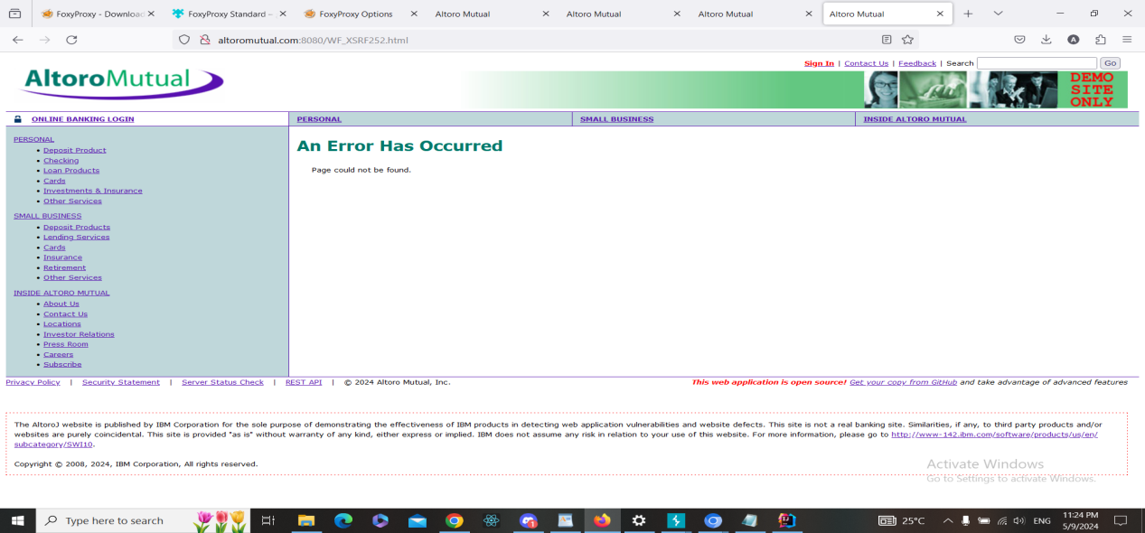

**b. Fixing Steps**

ID07

1- I spot the input in the code

2- I made input validation and/or output encoding as following

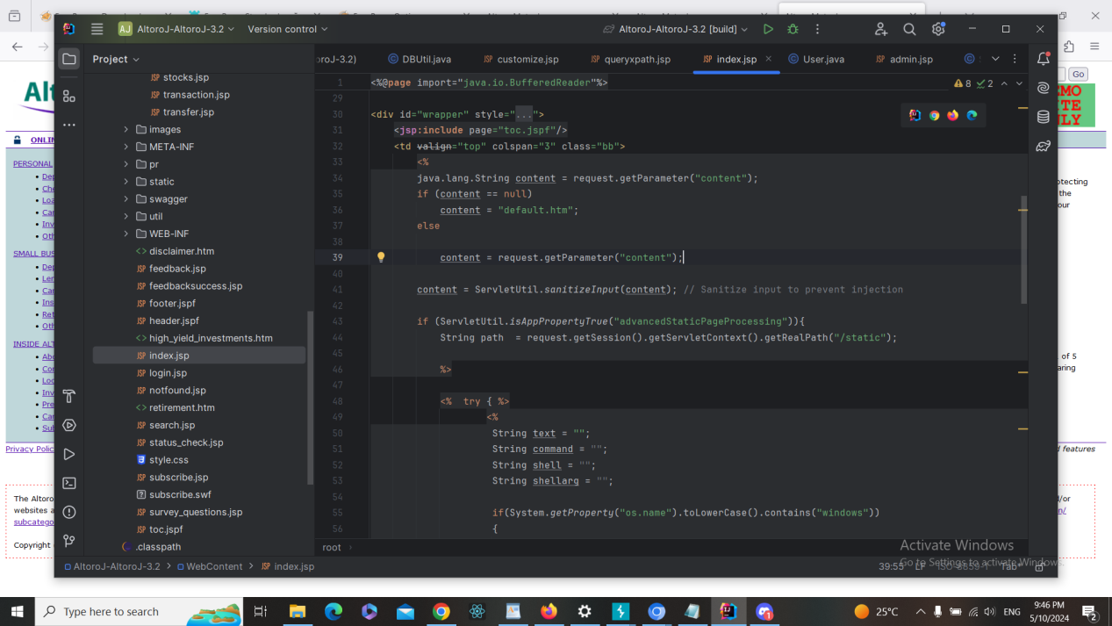

**c. Finding RE-Test Steps:**

ID07

1-Open the following page <https://demo.testfire.net/index.jsp>



2-Used Burp Suite to intercept the request



3-Added the following payload

?content="'><A HREF="/WF_XSRF252.html">Injected Link</A> HTTP/1.1

Or encoded payload

%3Fcontent%3D%22%27%3E%3CA%20HREF%3D%22%2FWF_XSRF252.html%22%3EInjected%0ALink%3C%2FA%3E%20HTTP%2F1.1%0A



4- The script has NOT run, and therefore, there is NO XSS vuln here. And the issue

is fixed + screenshot

**Finding details**

**Name: ID08: Link Injection Attack in Search search.jsp**

Test Severity: Medium

Test Score: 6.5

Retest Severity: Resolved

Description:

The search on the website (https://demo.testfire.net/search.jsp) is vulnerable to a link injection attack. This vulnerability arises when user-supplied input is not properly validated or sanitized before being included as part of a hyperlink. Attackers can exploit this vulnerability to inject malicious links into the page, potentially leading users to phishing websites, malware downloads, or other malicious content.

Impact:

Users may be directed to malicious websites without their knowledge or consent.

Malicious links injected into the page can lead to phishing attacks, where users unwittingly provide sensitive information.

It can damage the trustworthiness and reputation of the website among its users.

Recommendations:

Implement strict input validation and sanitization mechanisms to ensure that user-provided input is safe and does not contain malicious links.

Use proper encoding techniques, such as HTML escaping, to render user input safely within HTML content.

Regularly monitor and review the website's codebase for any signs of vulnerabilities, especially in areas where user input is utilized.

Educate users about the risks associated with clicking on unfamiliar or suspicious links and encourage them to exercise caution while browsing the website.

**Finding scenarios**

**a. Finding Test Steps:**

ID08

1. Open the following page <https://demo.testfire.net/search.jsp>

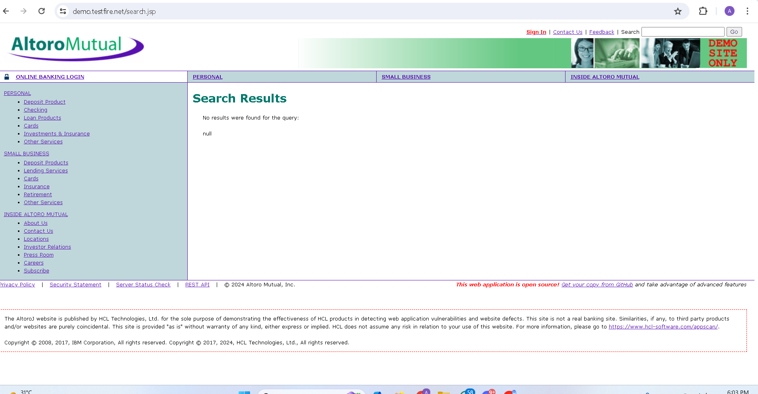

1. Used Burp Suite to intercept the request

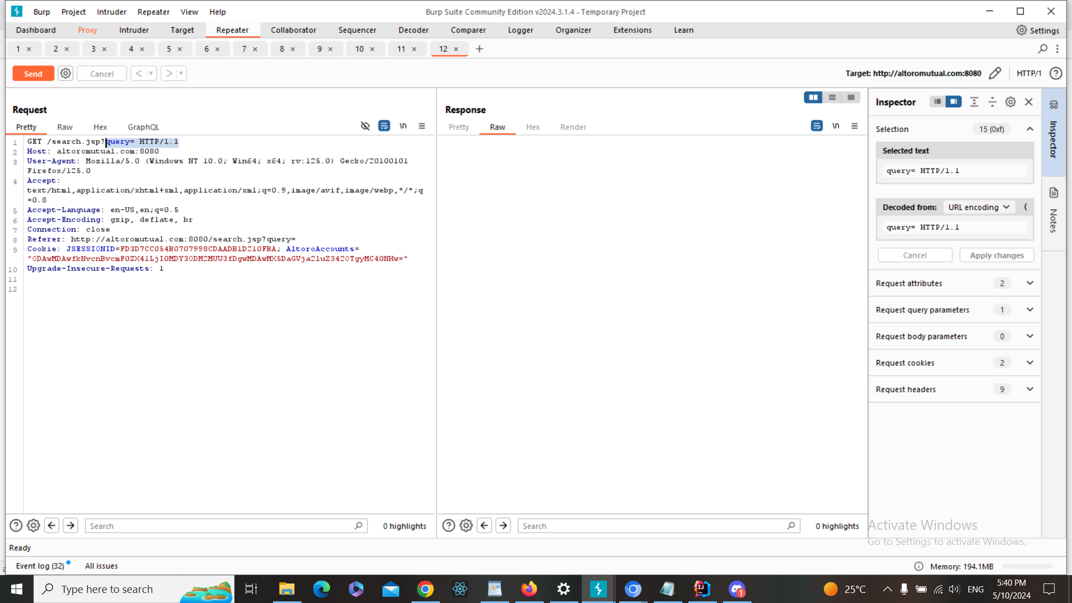

1. Added the following payload

"'><A HREF="/WF_XSRF252.html">Injected Link</A> HTTP/1.1\

Or encoded payload

%22%27%3E%3CA%20HREF%3D%22%2FWF_XSRF252.html%22%3EInjected%20Link%3C%2FA%3E%20HTTP%2F1.1

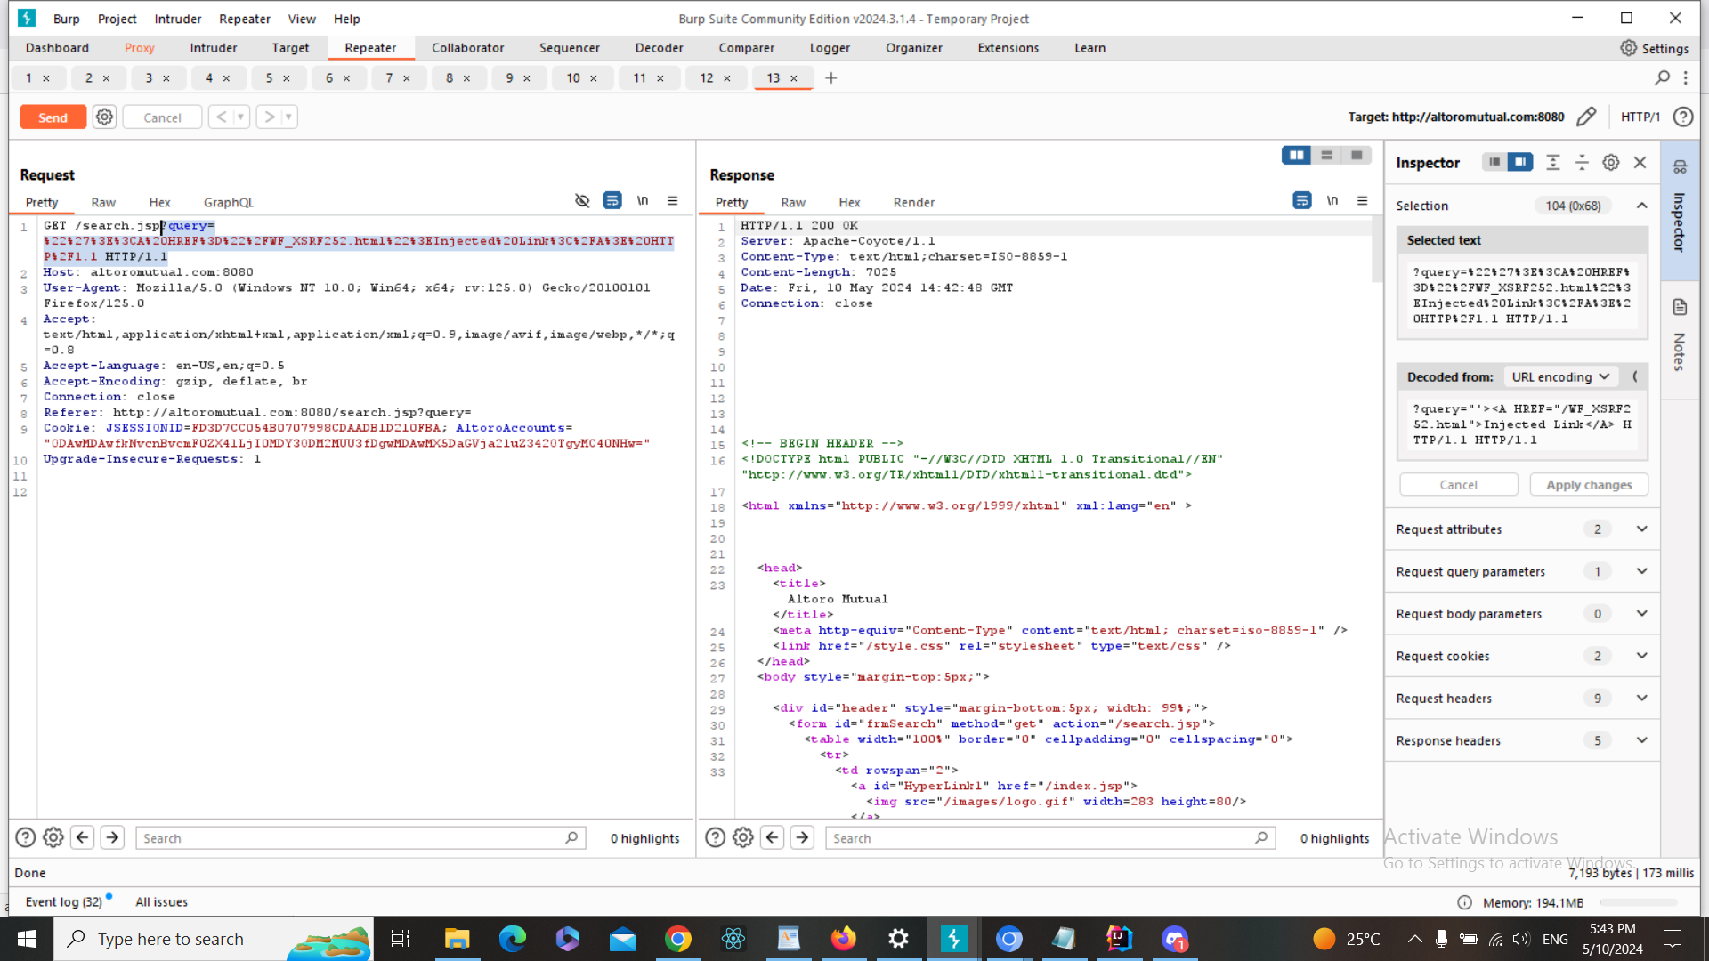

4-The injected link has successfully been added to the page , and therefore, there is Link Injection vuln here

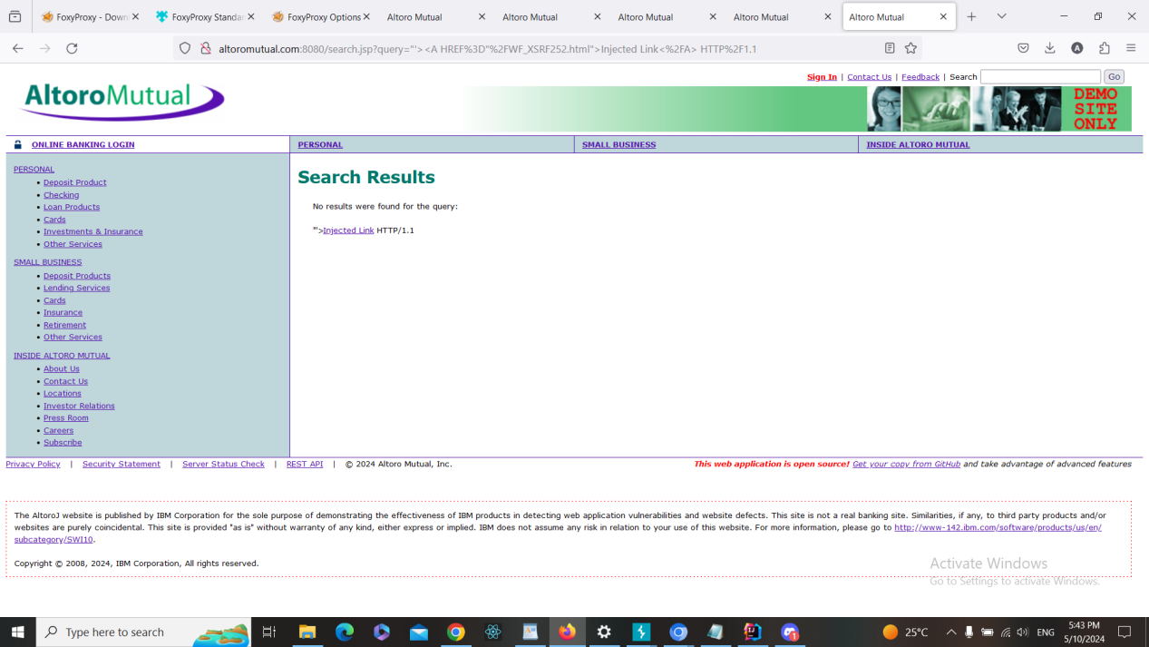

**b. Fixing Steps**

ID08

1- I spot the input in the code

2- I made input validation and/or output encoding as following + screenshot

**c. Finding RE-Test Steps:**

ID08

1-Open the following page <https://demo.testfire.net/search.jsp>



2-Used Burp Suite to intercept the request



3-Added the following payload

"'><A HREF="/WF_XSRF252.html">Injected Link</A> HTTP/1.1\

Or encoded payload

%22%27%3E%3CA%20HREF%3D%22%2FWF_XSRF252.html%22%3EInjected%20Link%3C%2FA%3E%20HTTP%2F1.1

4- The script has NOT run, and therefore, there is NO XSS vuln here. And the issue

is fixed + screenshot

**Finding details**

**Name: ID09: Link Injection Attack in Sending Feedback feedback.jsp**

Test Severity: Medium

Test Score: 6.5

Retest Severity: Resolved

Description:

Sending Feedback on the website at (https://demo.testfire.net/feedback.jsp) is vulnerable to a link injection attack. This vulnerability arises when user-supplied input is not properly validated or sanitized before being included as part of a hyperlink. Attackers can exploit this vulnerability to inject malicious links into the page, potentially leading users to phishing websites, malware downloads, or other malicious content.

Impact:

Users may be directed to malicious websites without their knowledge or consent.

Malicious links injected into the page can lead to phishing attacks, where users unwittingly provide sensitive information.

It can damage the trustworthiness and reputation of the website among its users.

Recommendations:

Implement strict input validation and sanitization mechanisms to ensure that user-provided input is safe and does not contain malicious links.

Use proper encoding techniques, such as HTML escaping, to render user input safely within HTML content.

Regularly monitor and review the website's codebase for any signs of vulnerabilities, especially in areas where user input is utilized.

Educate users about the risks associated with clicking on unfamiliar or suspicious links and encourage them to exercise caution while browsing the website.

**Finding scenarios**

**a. Finding Test Steps:**

ID09

1. Open the following page <https://demo.testfire.net/feedback.jsp>

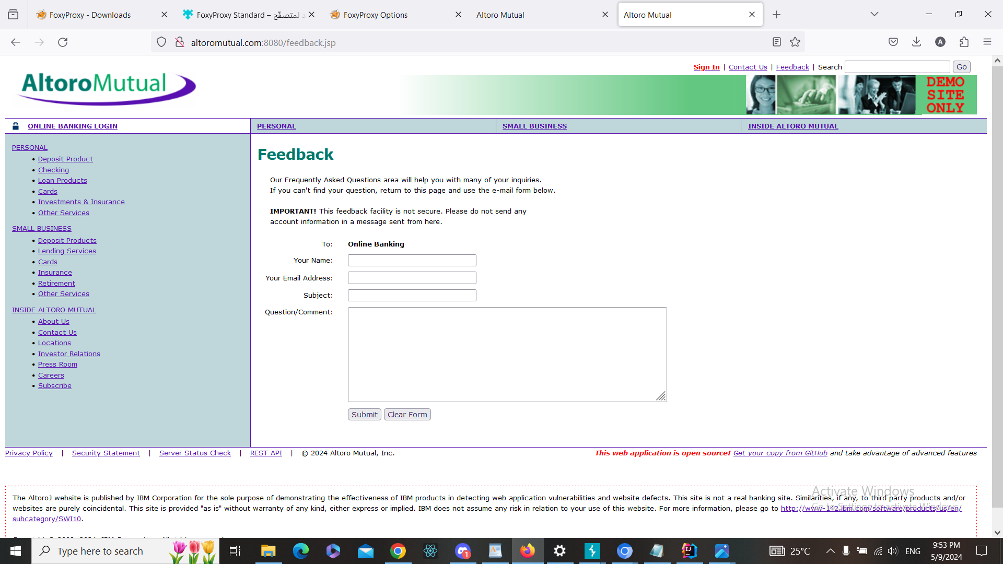

1. Used Burp Suite to intercept the request

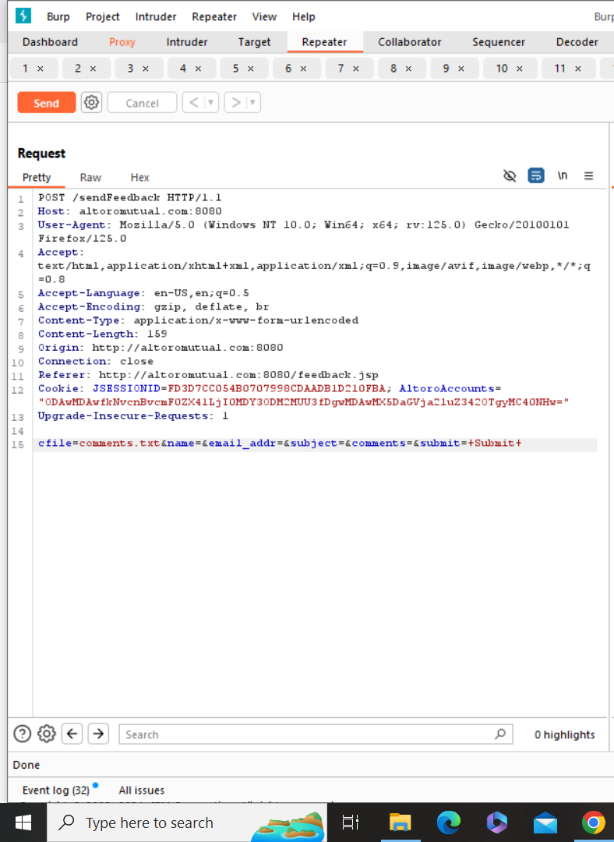

1. Added the following payload

"'><A HREF="/WF_XSRF252.html">Injected Link</A> HTTP/1.1\

Or encoded payload

%22%27%3E%3CA%20HREF%3D%22%2FWF_XSRF252.html%22%3EInjected%20Link%3C%2FA%3E%20HTTP%2F1.1

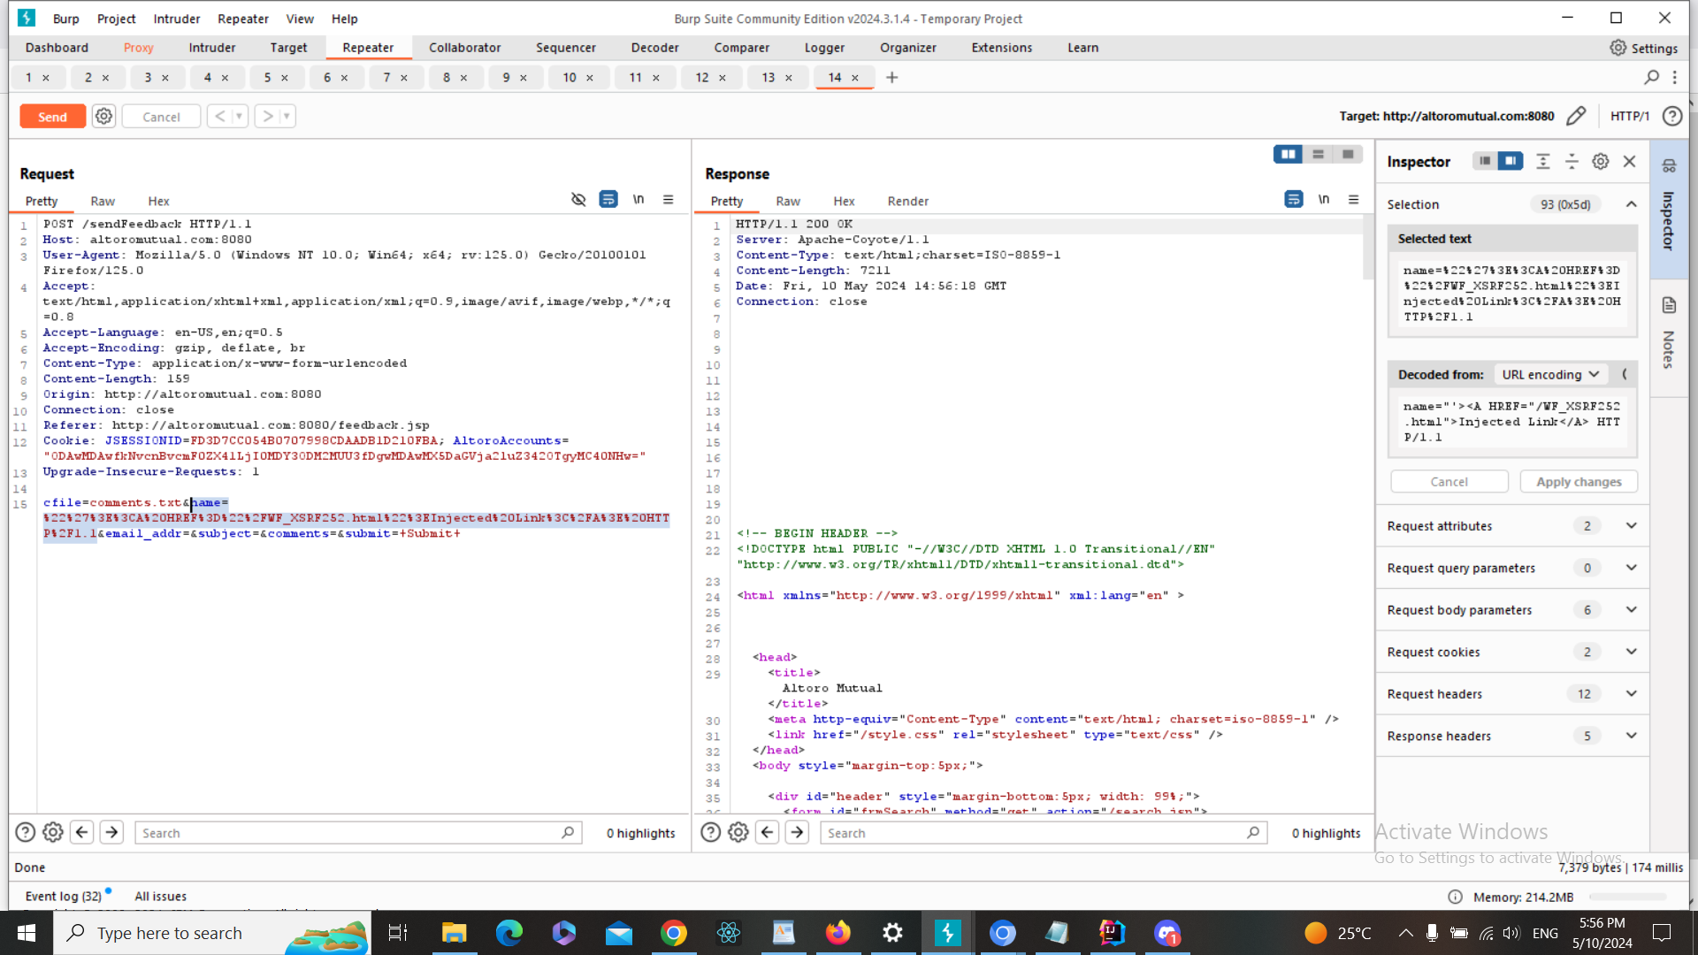

1. The injected link has successfully been added to the page , and therefore, there is Link Injection vuln here

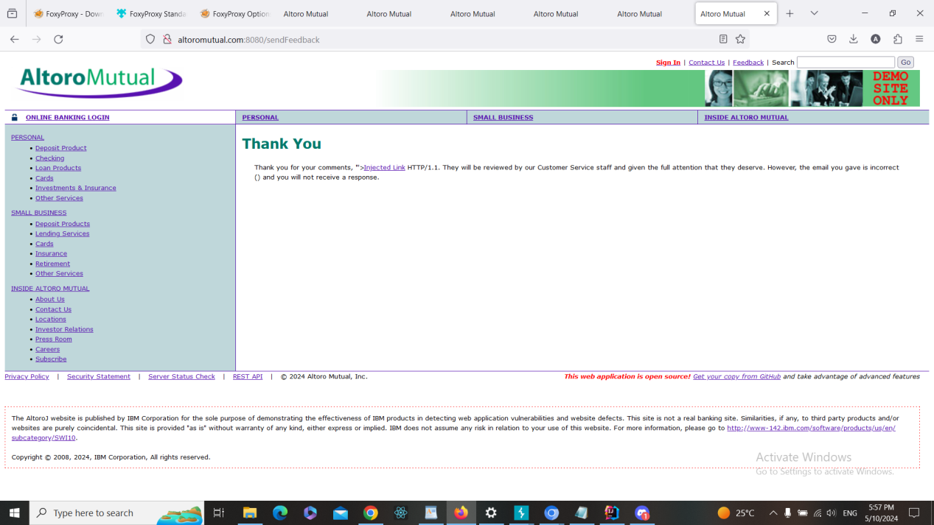

**b. Fixing Steps**

ID09

1- I spot the input in the code

2- I made input validation and/or output encoding as following

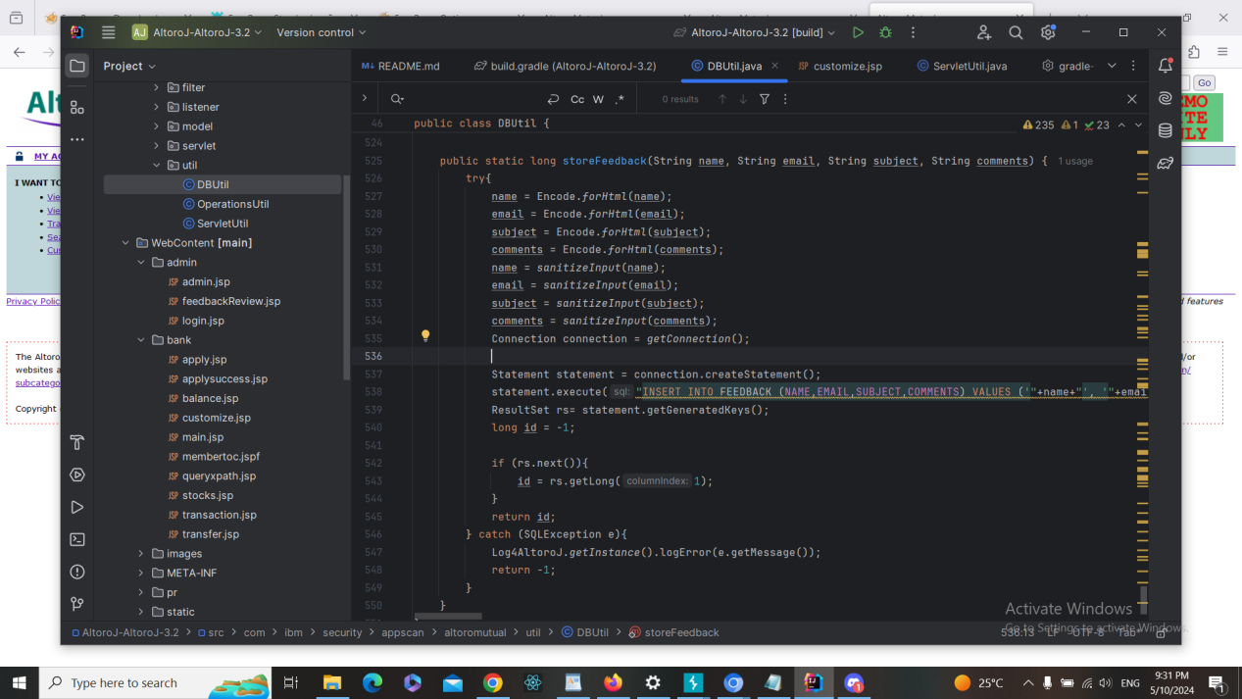

**c. Finding RE-Test Steps:**

ID09

1-Open the following page <https://demo.testfire.net/feedback.jsp>



2-Used Burp Suite to intercept the request



3-Added the following payload

"'><A HREF="/WF_XSRF252.html">Injected Link</A> HTTP/1.1\

Or encoded payload

%22%27%3E%3CA%20HREF%3D%22%2FWF_XSRF252.html%22%3EInjected%20Link%3C%2FA%3E%20HTTP%2F1.1

4- The script has NOT run, and therefore, there is NO XSS vuln here. And the issue

is fixed + screenshot

**Finding details**

**Name: ID10: Link Injection Attack in Customize Site Language**

Test Severity: Medium

Test Score: 6.5

Retest Severity: Resolved

Description:

Customize Language on the website at (https://demo.testfire.net/bank/customize.jsp) is vulnerable to a link injection attack. This vulnerability arises when user-supplied input is not properly validated or sanitized before being included as part of a hyperlink. Attackers can exploit this vulnerability to inject malicious links into the page, potentially leading users to phishing websites, malware downloads, or other malicious content.

Impact:

Users may be directed to malicious websites without their knowledge or consent.

Malicious links injected into the page can lead to phishing attacks, where users unwittingly provide sensitive information.

It can damage the trustworthiness and reputation of the website among its users.

Recommendations:

Implement strict input validation and sanitization mechanisms to ensure that user-provided input is safe and does not contain malicious links.

Use proper encoding techniques, such as HTML escaping, to render user input safely within HTML content.

Regularly monitor and review the website's codebase for any signs of vulnerabilities, especially in areas where user input is utilized.

Educate users about the risks associated with clicking on unfamiliar or suspicious links and encourage them to exercise caution while browsing the website.

**Finding scenarios**

**a. Finding Test Steps:**

ID10

1. Open the following page <https://demo.testfire.net/bank/customize.jsp> and choose any language

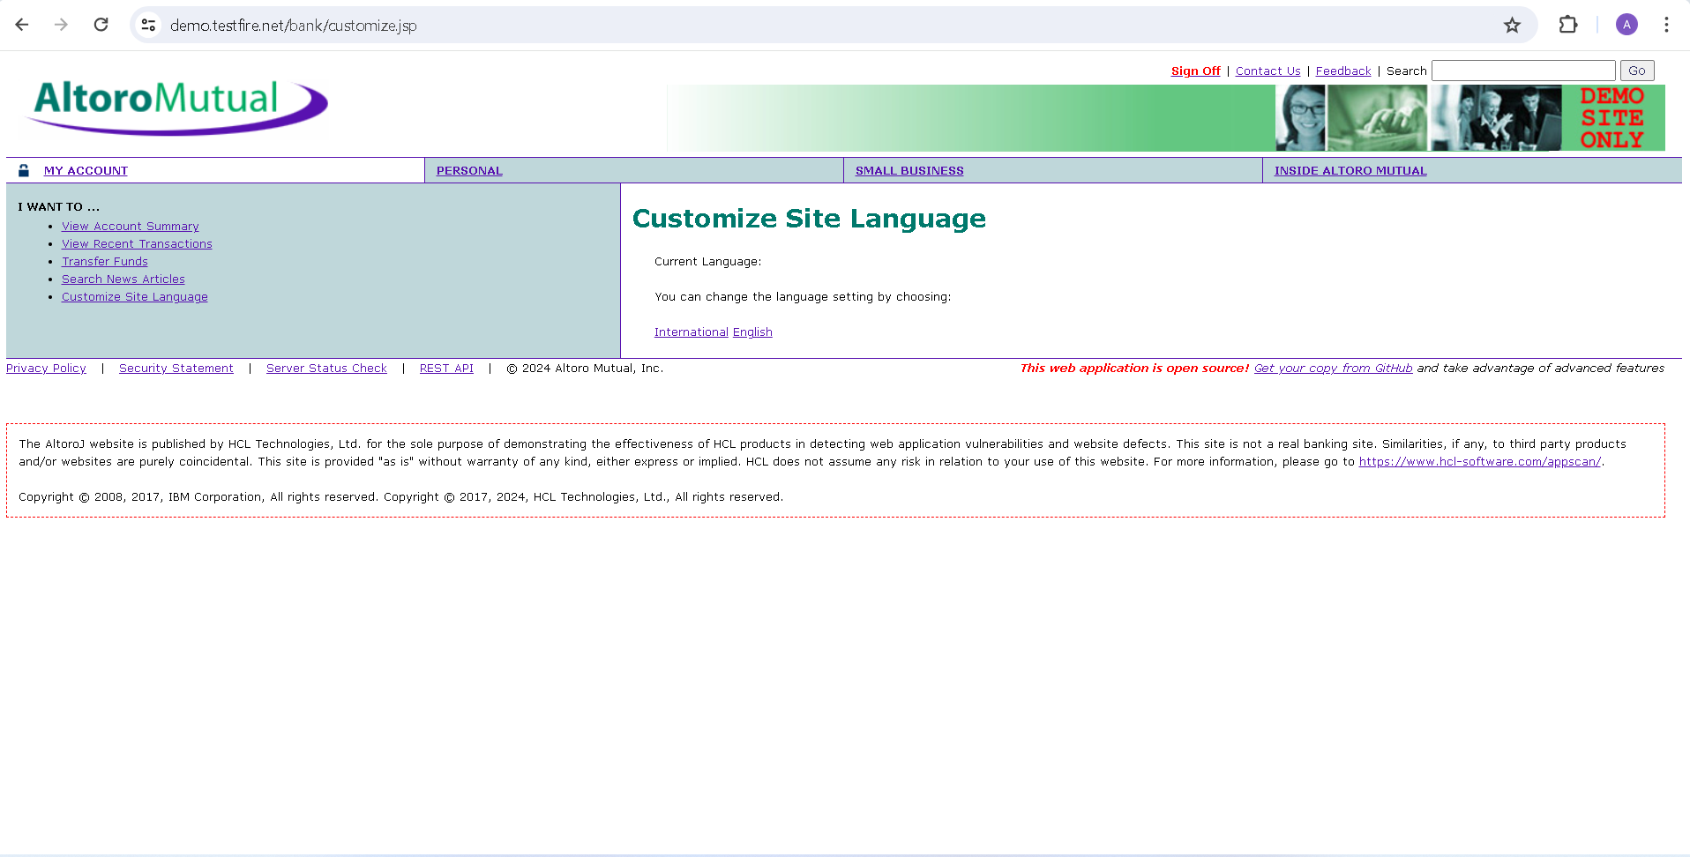

2-Used Burp Suite to intercept the request

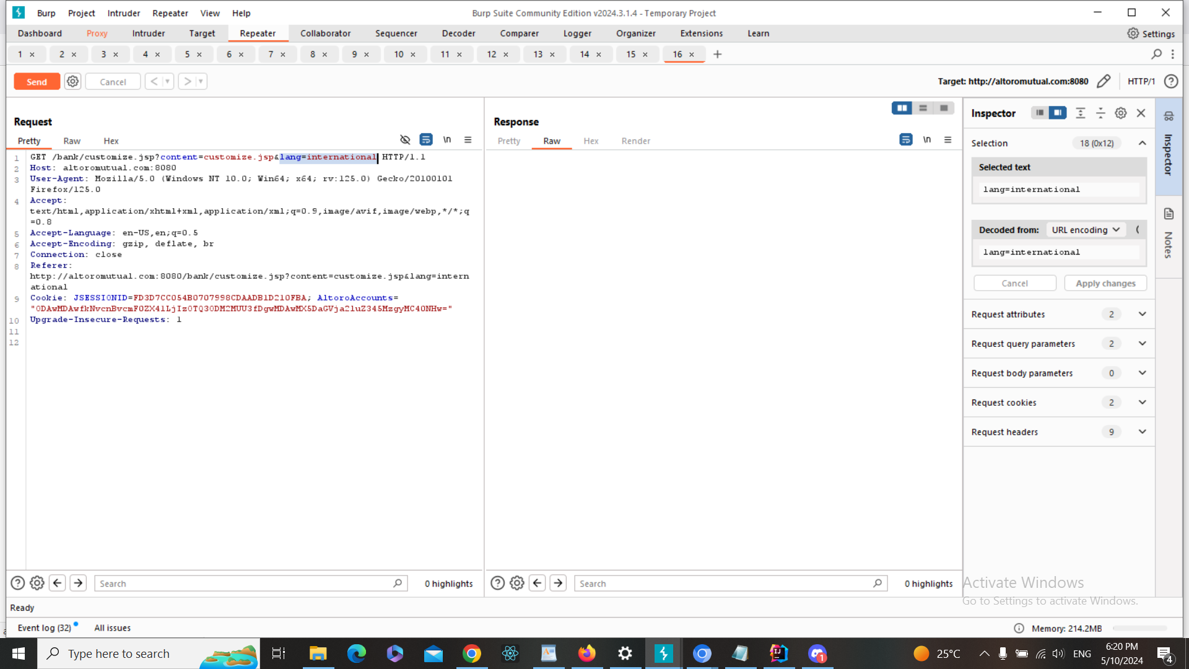

3-"'><A HREF="/WF_XSRF252.html">Injected Link</A> HTTP/1.1\

Or encoded payload

%22%27%3E%3CA%20HREF%3D%22%2FWF_XSRF252.html%22%3EInjected%20Link%3C%2FA%3E%20HTTP%2F1.1

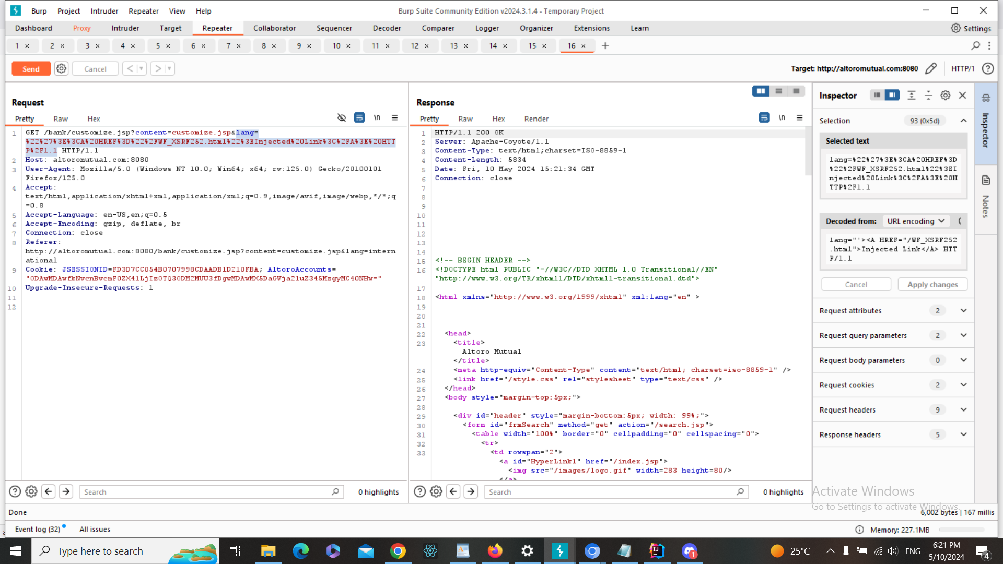

4- The injected link has successfully been added to the page , and therefore, there is Link Injection vuln here

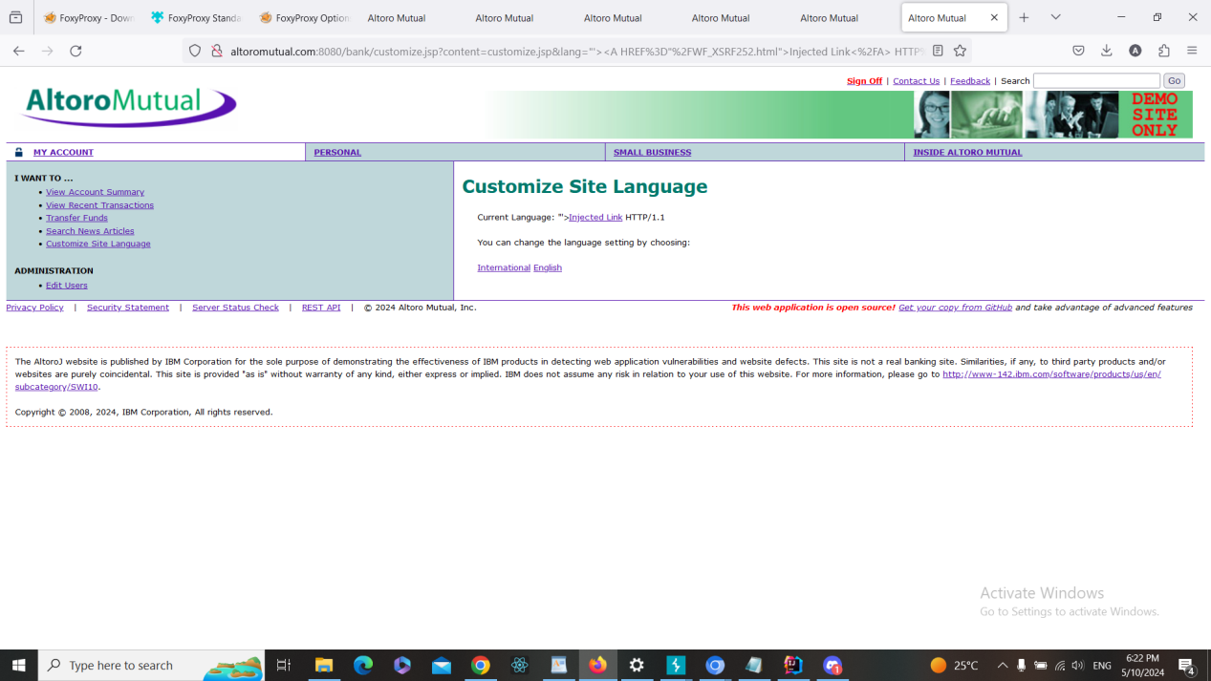

**b. Fixing Steps**

ID010

1- I spot the input in the code

2- I made input validation and/or output encoding as following

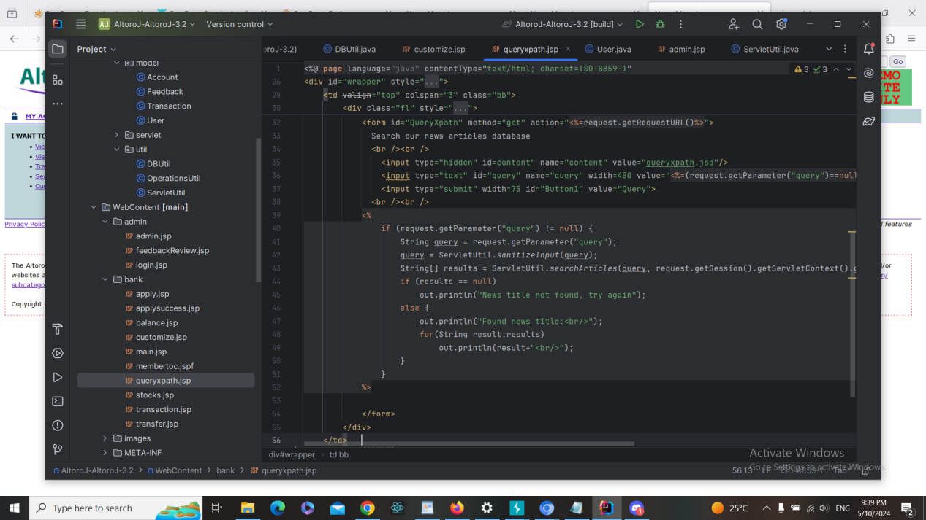

**c. Finding RE-Test Steps:**

ID010

1-Open the following page <https://demo.testfire.net/bank/customize.jsp> and choose any language



2-Used Burp Suite to intercept the request



3-"'><A HREF="/WF_XSRF252.html">Injected Link</A> HTTP/1.1\

Or encoded payload

%22%27%3E%3CA%20HREF%3D%22%2FWF_XSRF252.html%22%3EInjected%20Link%3C%2FA%3E%20HTTP%2F1.1

4- The script has NOT run, and therefore, there is NO XSS vuln here. And the issue

is fixed + screenshot

**Finding details**

**Name: ID11: Link Injection Attack in Search New Articles**

Test Severity: Medium

Test Score: 6.5

Retest Severity: Resolved

Description:

Search For New Articles on the website at (https://demo.testfire.net/bank/queryxpath.jsp) is vulnerable to a link injection attack. This vulnerability arises when user-supplied input is not properly validated or sanitized before being included as part of a hyperlink. Attackers can exploit this vulnerability to inject malicious links into the page, potentially leading users to phishing websites, malware downloads, or other malicious content.

Impact:

Users may be directed to malicious websites without their knowledge or consent.

Malicious links injected into the page can lead to phishing attacks, where users unwittingly provide sensitive information.

It can damage the trustworthiness and reputation of the website among its users.

Recommendations:

Implement strict input validation and sanitization mechanisms to ensure that user-provided input is safe and does not contain malicious links.

Use proper encoding techniques, such as HTML escaping, to render user input safely within HTML content.

Regularly monitor and review the website's codebase for any signs of vulnerabilities, especially in areas where user input is utilized.

Educate users about the risks associated with clicking on unfamiliar or suspicious links and encourage them to exercise caution while browsing the website.

**Finding scenarios**

**a. Finding Test Steps:**

ID11

1. Open the following page <https://demo.testfire.net/bank/queryxpath.jsp>

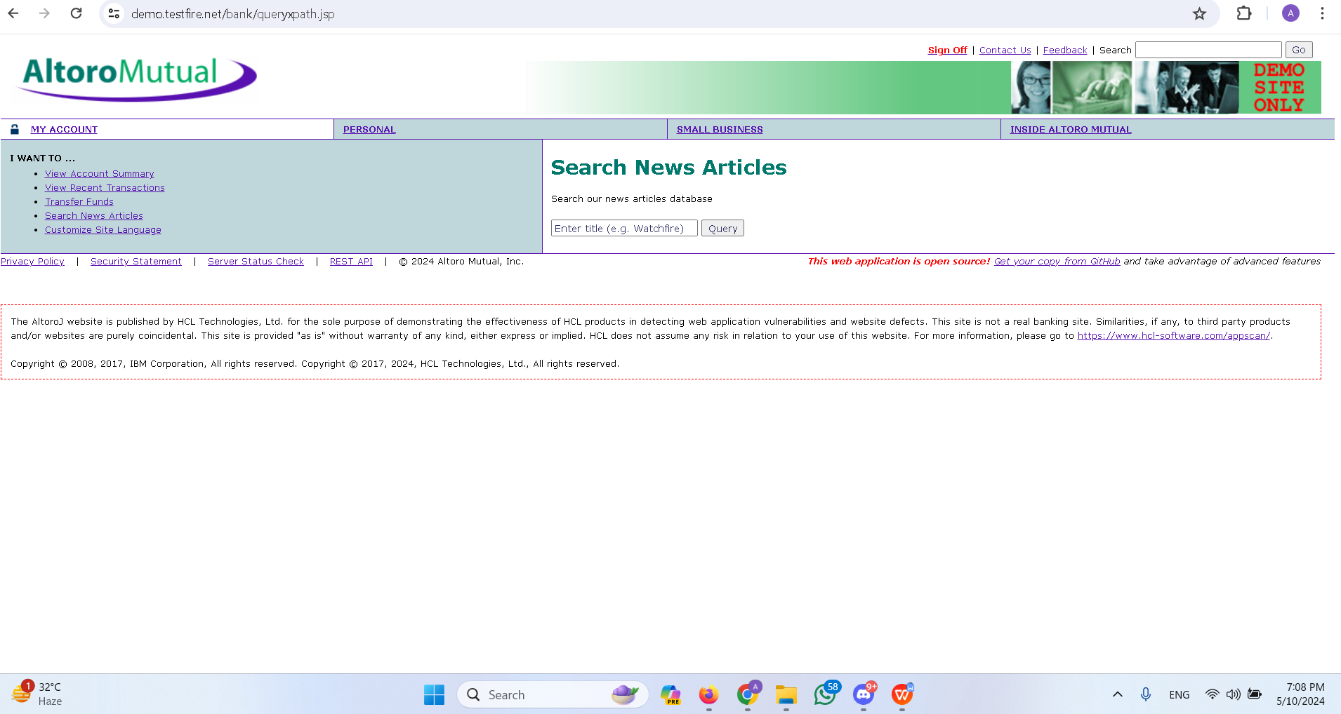

1. Used Burp Suite to intercept the request

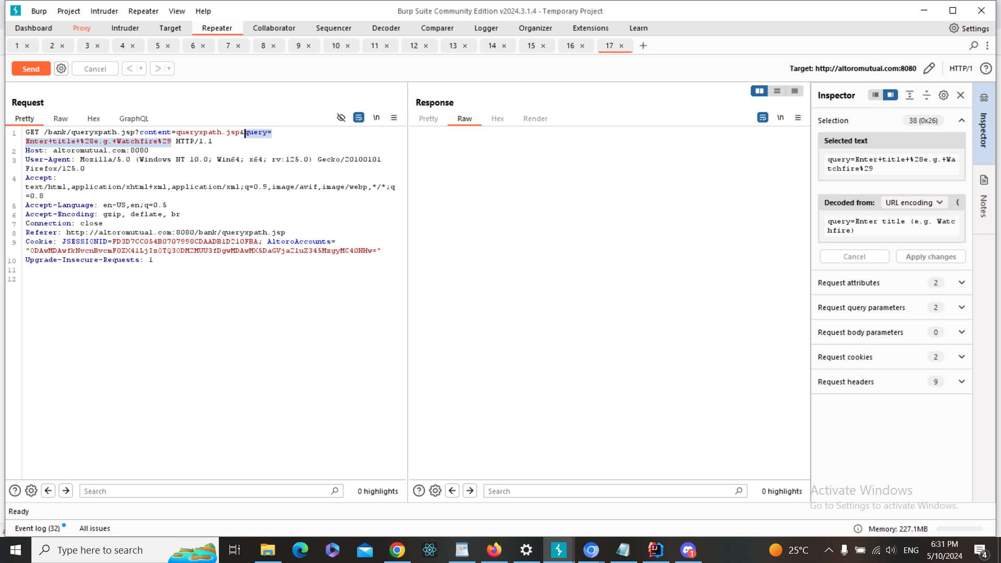

1. Added the following payload in query =

'><A HREF="/WF_XSRF252.html">Injected Link</A> HTTP/1.1\

Or encoded payload

%22%27%3E%3CA%20HREF%3D%22%2FWF_XSRF252.html%22%3EInjected%20Link%3C%2FA%3E%20HTTP%2F1.1

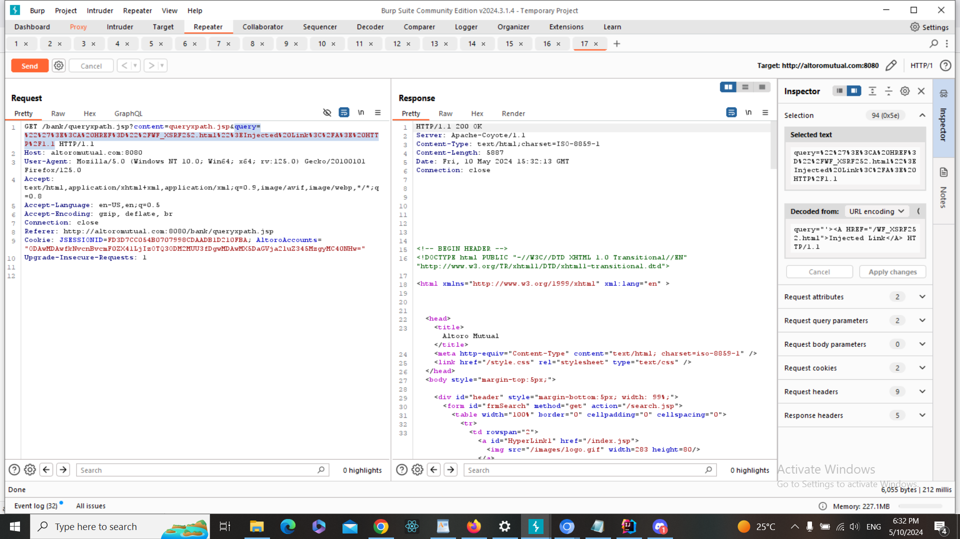

4-The injected link has successfully been added to the page , and therefore, there is Link Injection vuln here

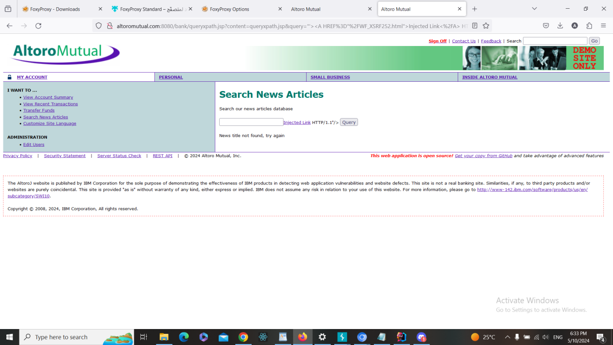

**b. Fixing Steps**

ID11

1- I spot the input in the code

2- I made input validation and/or output encoding as following + screenshot

**c. Finding RE-Test Steps:**

ID11

1-Open the following page <https://demo.testfire.net/bank/queryxpath.jsp>



2-Used Burp Suite to intercept the request



3-Added the following payload in query =

'><A HREF="/WF_XSRF252.html">Injected Link</A> HTTP/1.1\

Or encoded payload

%22%27%3E%3CA%20HREF%3D%22%2FWF_XSRF252.html%22%3EInjected%20Link%3C%2FA%3E%20HTTP%2F1.1

4- The script has NOT run, and therefore, there is NO XSS vuln here. And the issue

is fixed + screenshot

**Finding details**

**Name: ID12:SQL Injection Vulnerability in Show Transaction (Start Date)**

Test Severity: Critical

Test Score: 9.4

Retest Severity: Resolved

Description:

The Show Transaction page on the website (https://demo.testfire.net/bank/transaction.jsp) is vulnerable to SQL injection through the Start Date parameter. This vulnerability allows attackers to manipulate the SQL query executed by the backend database by injecting malicious SQL code into the Start Date parameter.

Impact:

The SQL injection vulnerability could allow attackers to access sensitive information stored in the database, such as user credentials, financial transactions, or personal data.

Attackers could potentially modify or delete data, leading to data loss or integrity breaches.

The exploitation of this vulnerability could result in a complete compromise of the application's security and the exposure of confidential information.

Recommendations:

1-Implement parameterized queries or prepared statements to mitigate SQL injection vulnerabilities. This ensures that user input is properly sanitized before being used in SQL queries.

2-Educate developers about secure coding practices, including input validation and parameterized queries, to prevent SQL injection attacks.

3-Monitor database logs and audit trails for suspicious activities, such as unauthorized access or SQL injection attempts, and take appropriate action to mitigate risks

**Finding scenarios**

**a. Finding Test Steps:**

ID12

1. Open the following page <https://demo.testfire.net/bank/transaction.jsp>

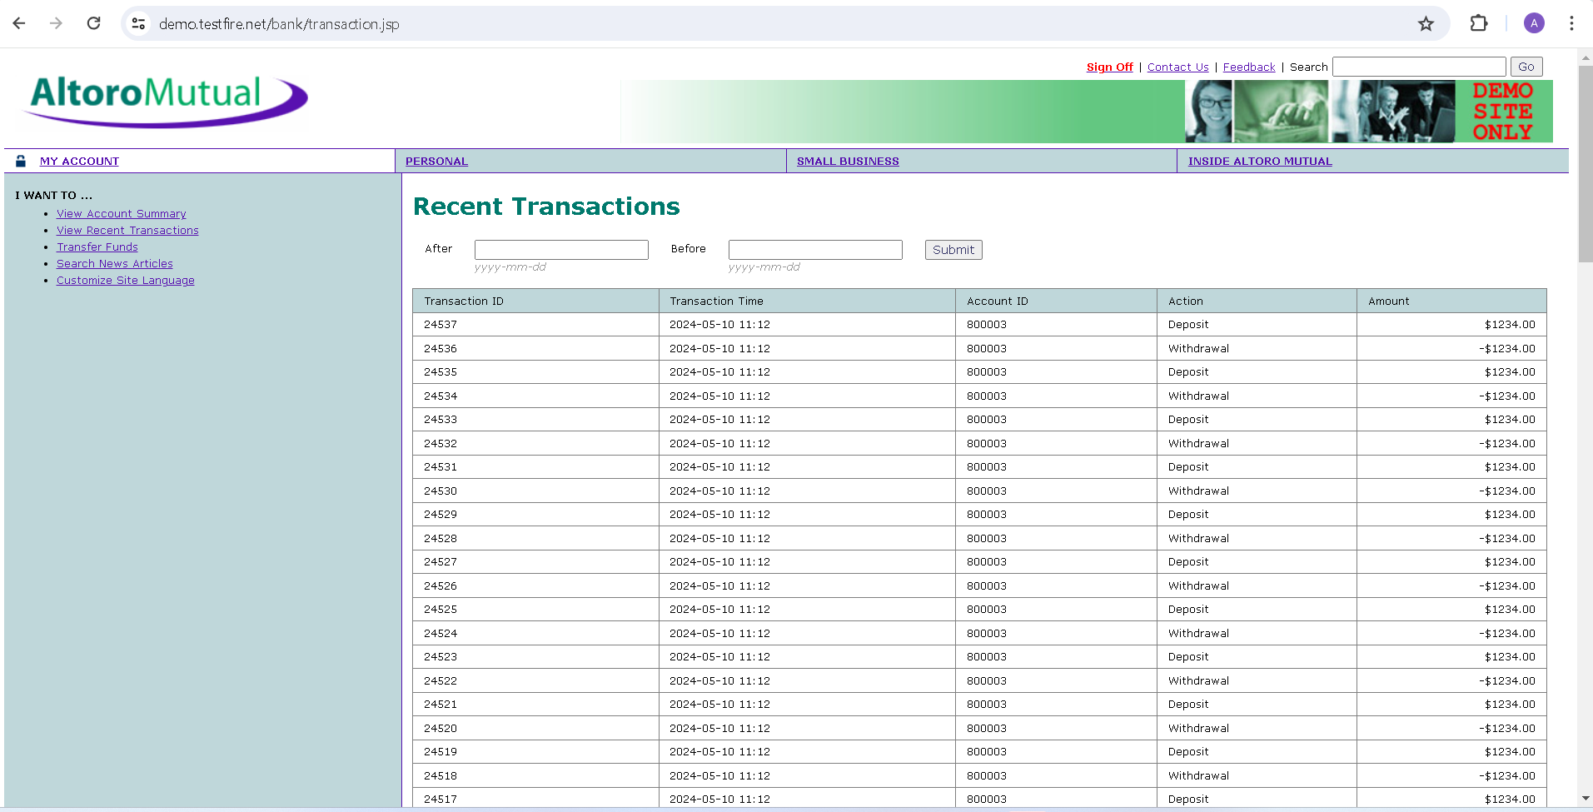

1. Used Burp Suite to intercept the request

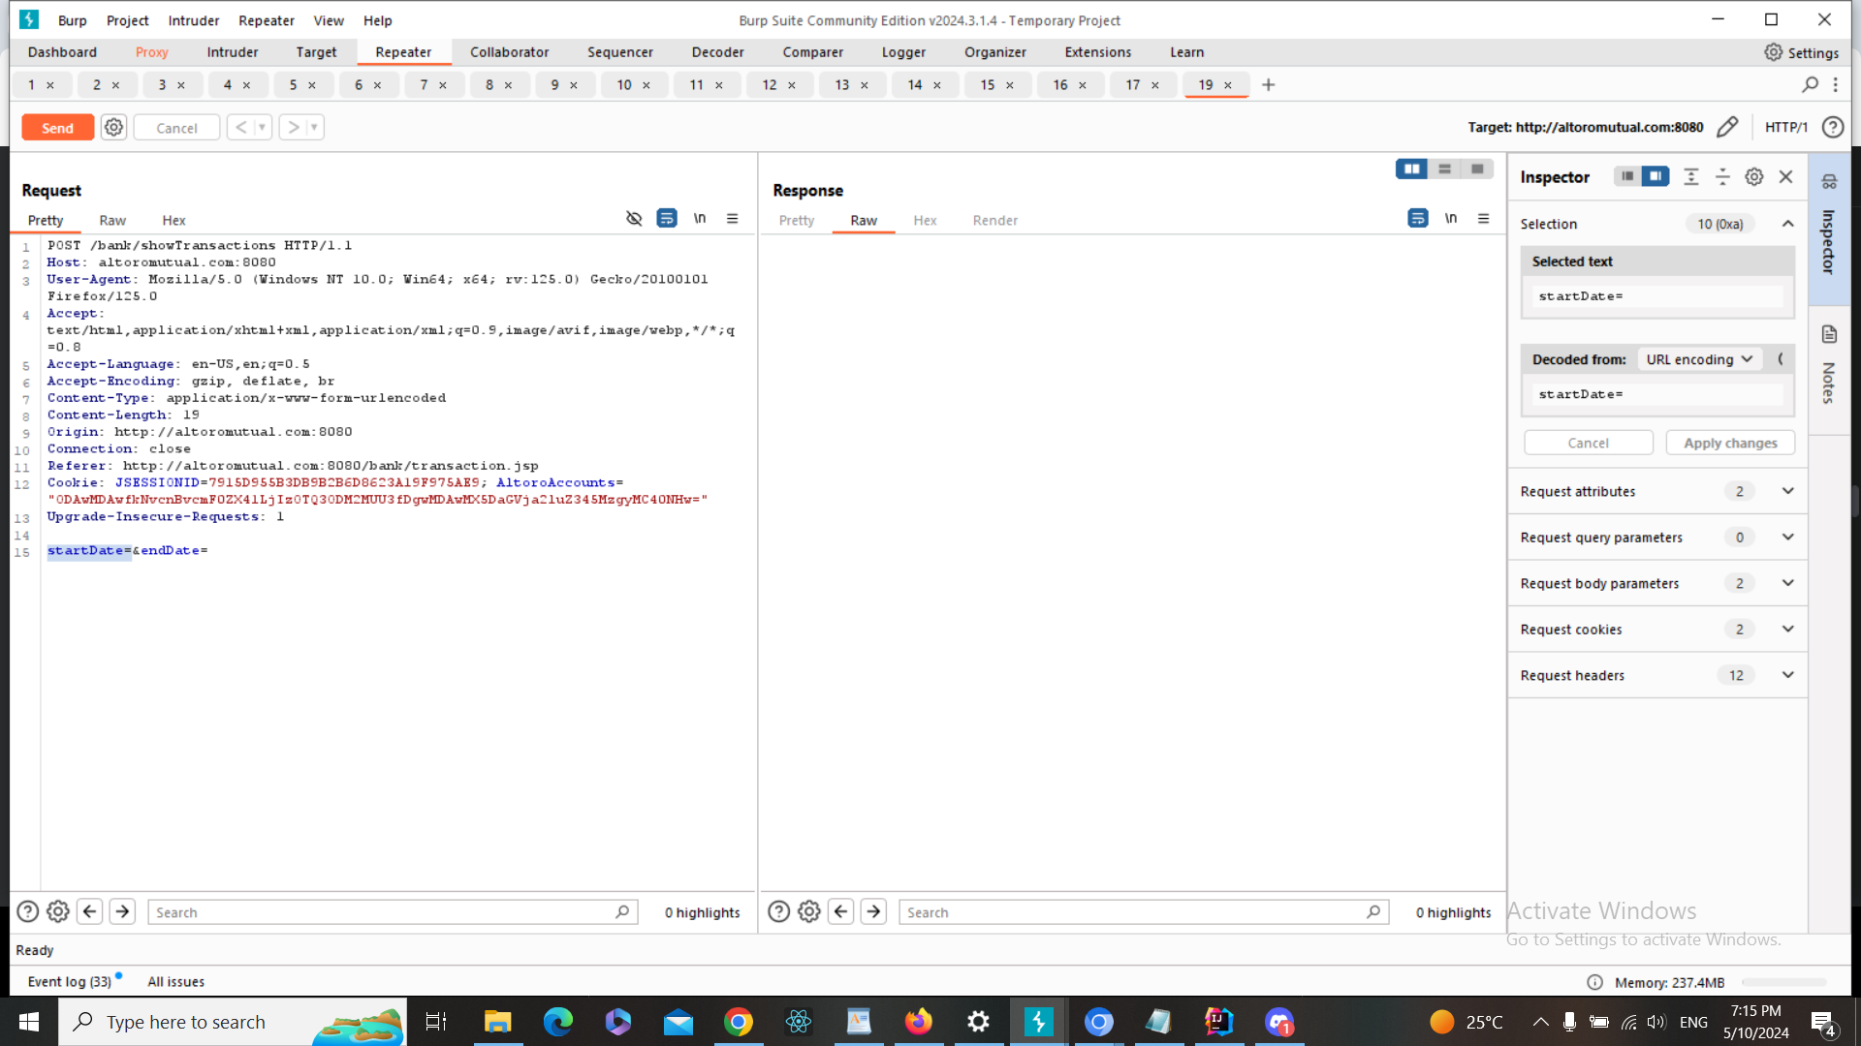

1. Added the following payload 2019-01-01%27%3B in startDate

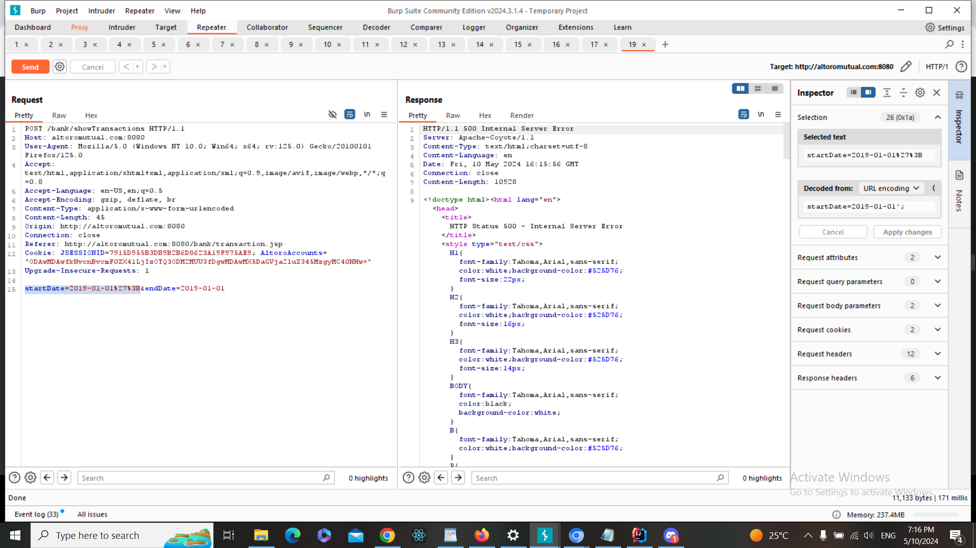

4-The injection was successful , and therefore, there is SQL injection vuln here

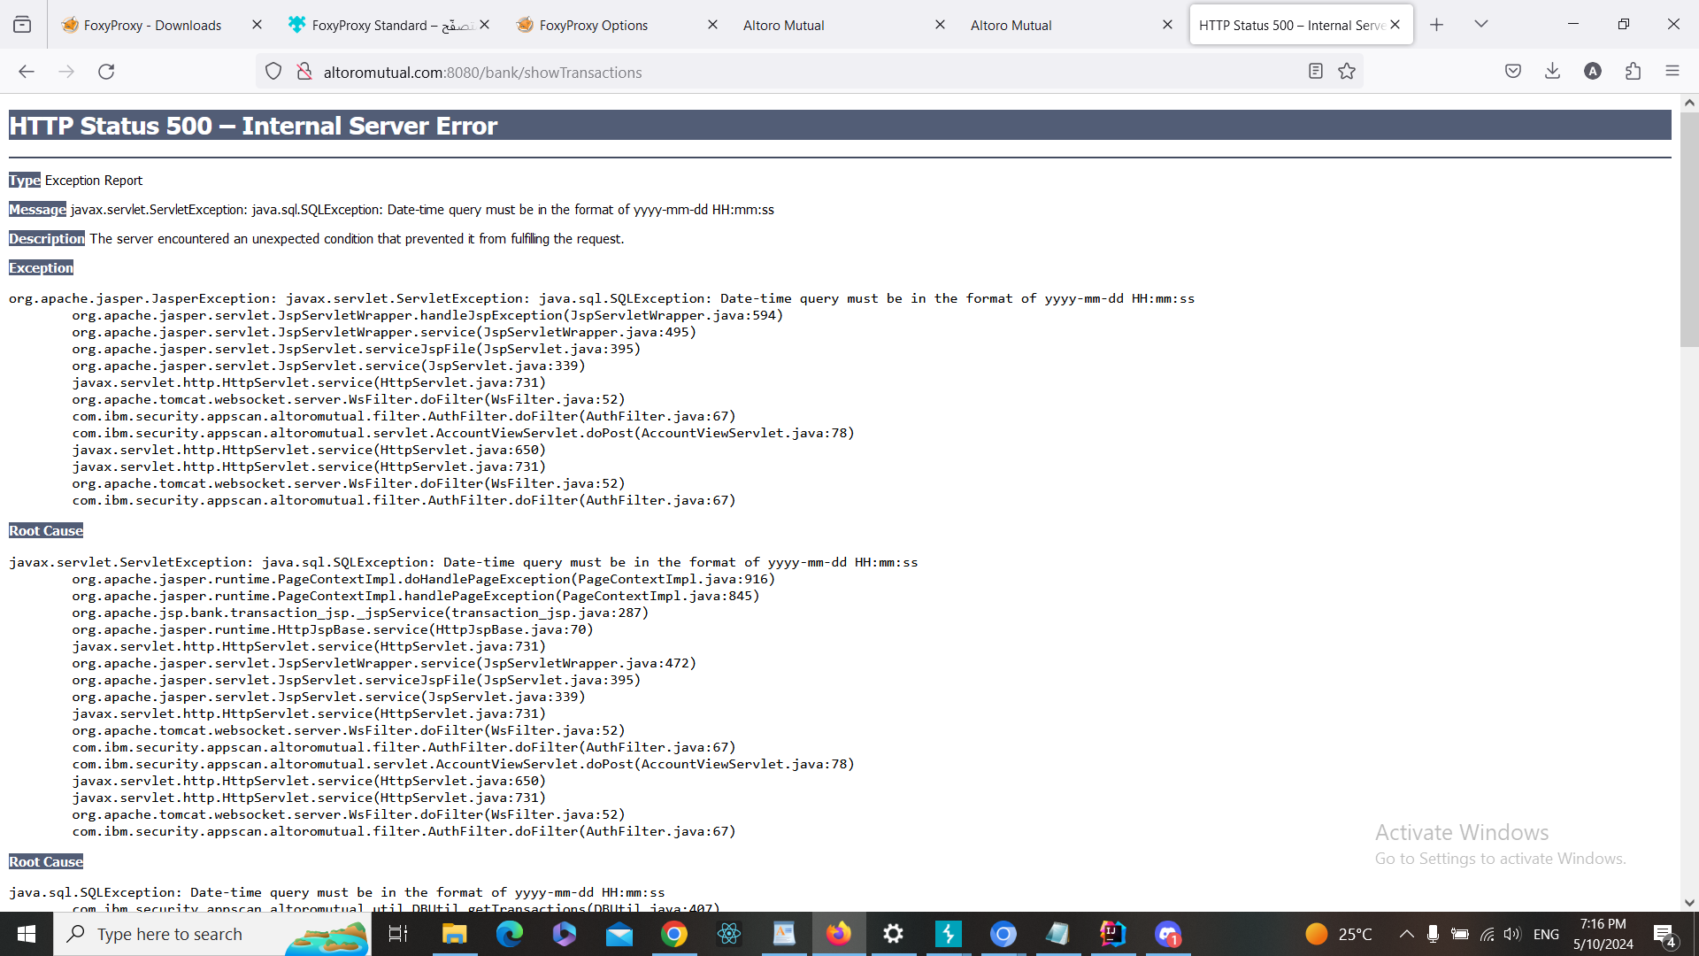

**b. Fixing Steps**

ID12

1- I spot the input in the code

2- I made input validation and/or output encoding as following

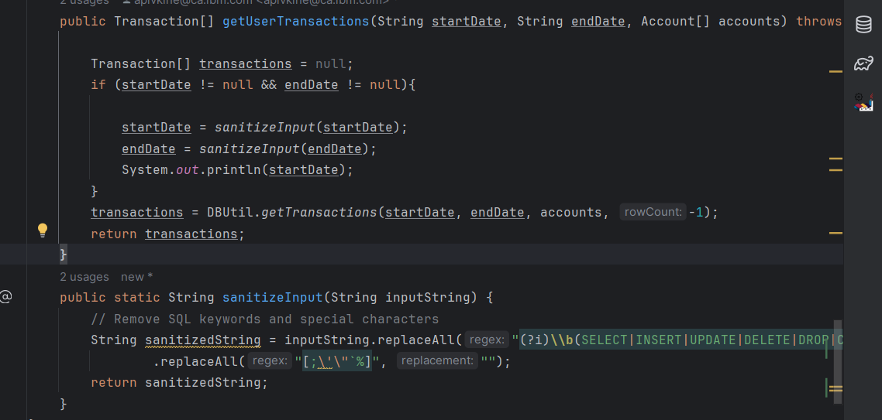

**c. Finding RE-Test Steps:**

ID12

1-Open the following page <https://demo.testfire.net/bank/transaction.jsp>



2-Used Burp Suite to intercept the request



3-Added the following payload 2019-01-01%27%3B in startDate



4- The script has NOT run, and therefore, there is NO XSS vuln here. And the issue

is fixed + screenshot

**Finding details**

**Name: ID13:SQL Injection Vulnerability in Show Transaction (End Date)**

Test Severity: Critical

Test Score: 9.4

Retest Severity: Resolved

Description:

The Show Transaction page on the website (https://demo.testfire.net/bank/transaction.jsp) is vulnerable to SQL injection through the End Date parameter. This vulnerability allows attackers to manipulate the SQL query executed by the backend database by injecting malicious SQL code into the End Date parameter.

Impact:

The SQL injection vulnerability could allow attackers to access sensitive information stored in the database, such as user credentials, financial transactions, or personal data.

Attackers could potentially modify or delete data, leading to data loss or integrity breaches.

The exploitation of this vulnerability could result in a complete compromise of the application's security and the exposure of confidential information.

Recommendations:

1-Implement parameterized queries or prepared statements to mitigate SQL injection vulnerabilities. This ensures that user input is properly sanitized before being used in SQL queries.

2-Educate developers about secure coding practices, including input validation and parameterized queries, to prevent SQL injection attacks.

3-Monitor database logs and audit trails for suspicious activities, such as unauthorized access or SQL injection attempts, and take appropriate action to mitigate risks

**Finding scenarios**

**a. Finding Test Steps:**

ID13

1. Open the following page <https://demo.testfire.net/bank/transaction.jsp>



2-Used Burp Suite to intercept the request

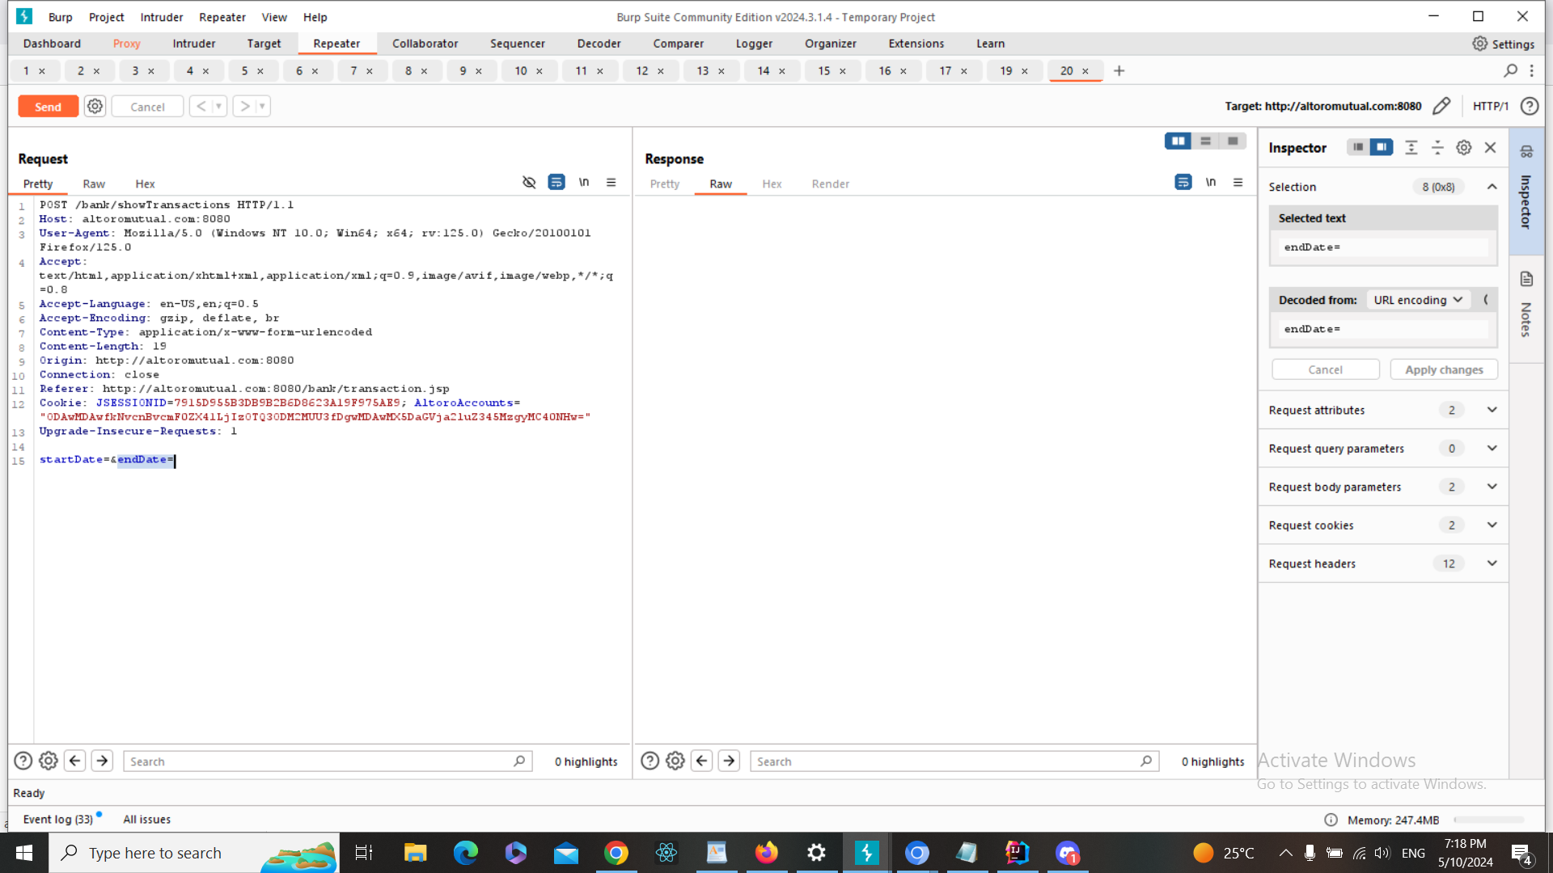

3-Added the following payload 2019-01-01%27%3B in endDate

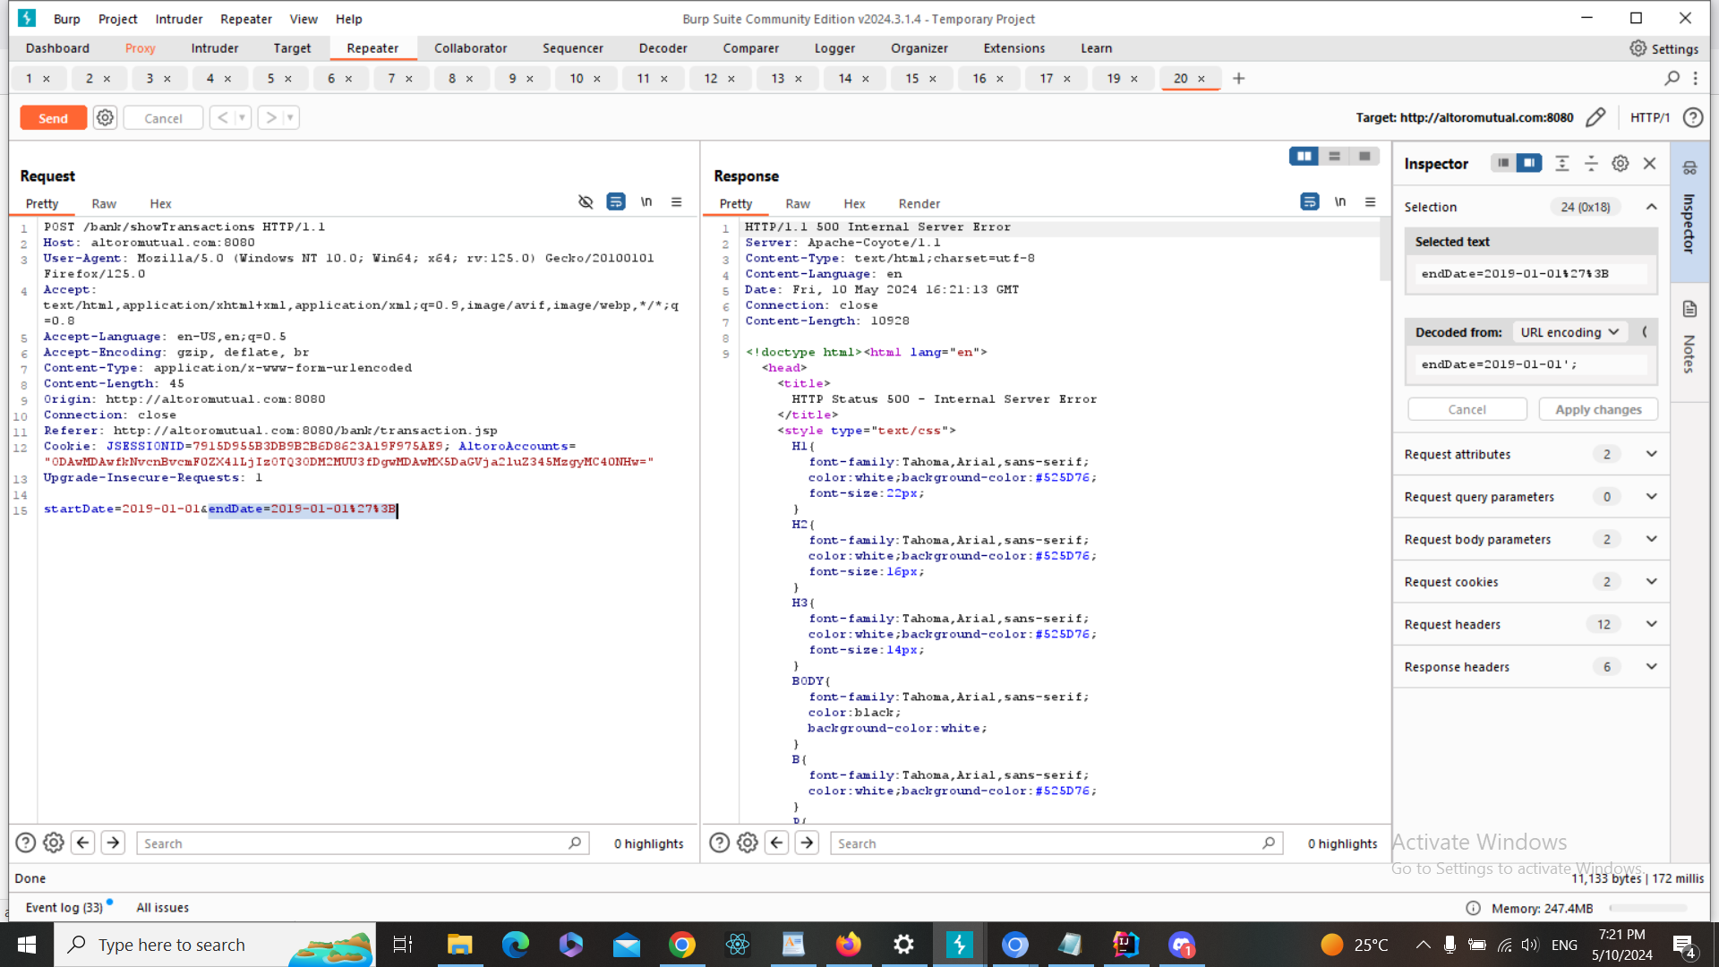

1. The injection was successful , and therefore, there is SQL injection vuln here

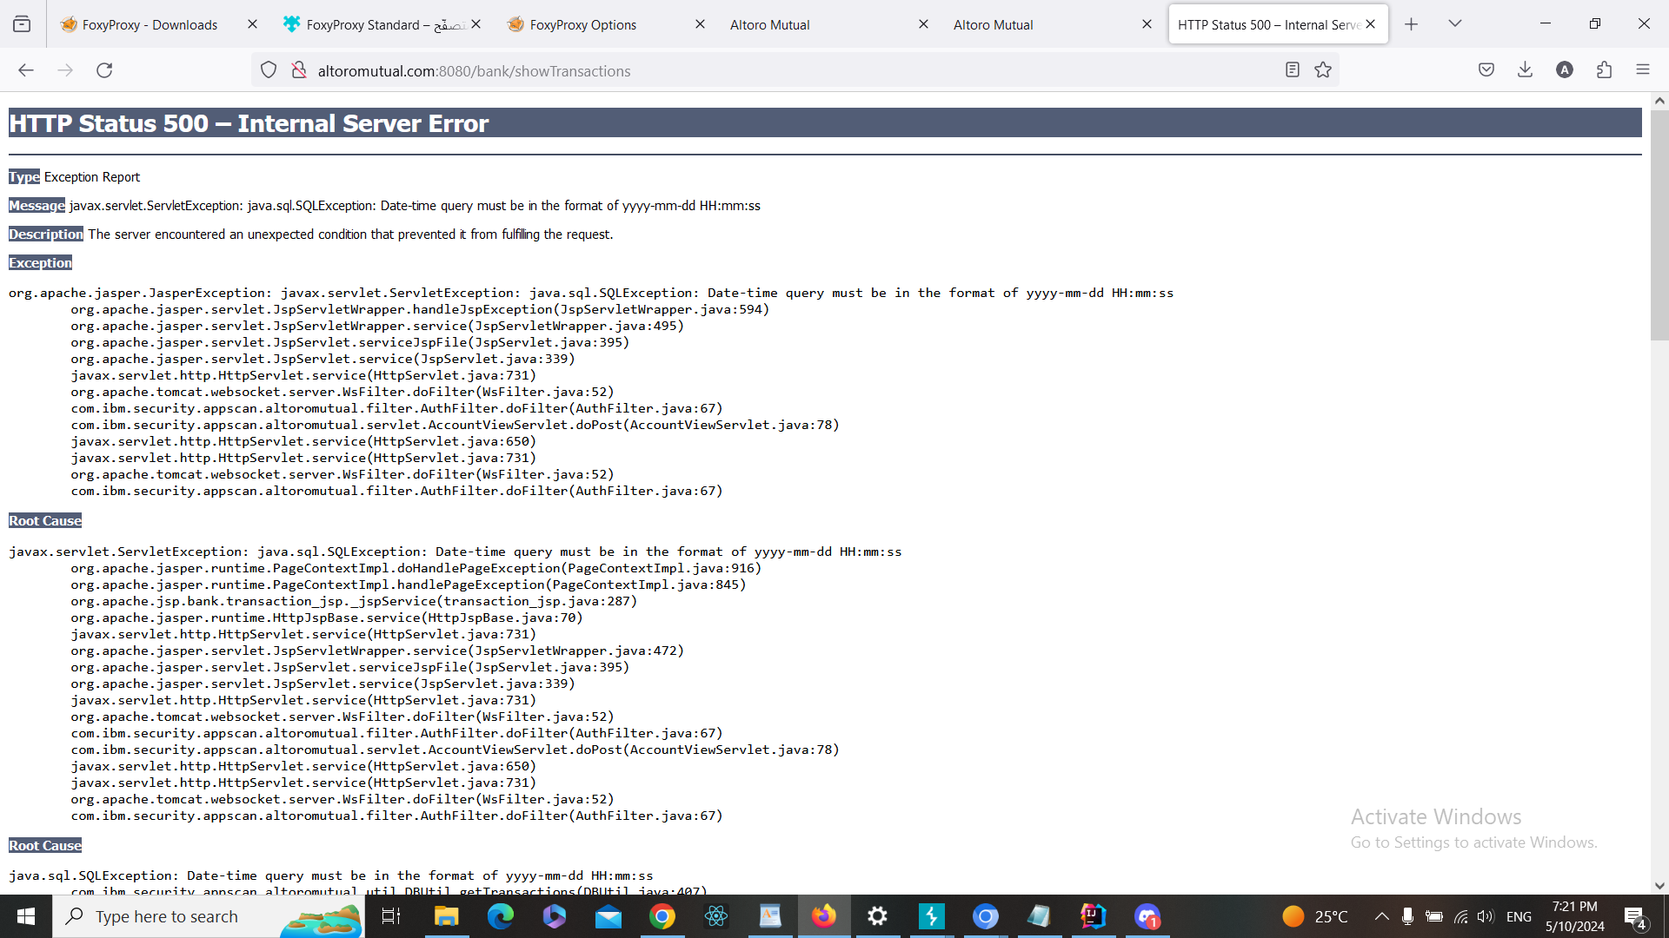

**b. Fixing Steps**

ID13

1- I spot the input in the code

2- I made input validation and/or output encoding as following



**c. Finding RE-Test Steps:**

ID13

1-Open the following page <https://demo.testfire.net/bank/transaction.jsp>



2-Used Burp Suite to intercept the request



3-Added the following payload 2019-01-01%27%3B in endDate



4- The script has NOT run, and therefore, there is NO XSS vuln here. And the issue

is fixed + screenshot

**Finding details**

**Name: ID14: Direct Access To Admin Page**

Test Severity: Medium

Test Score: 5.3

Retest Severity: Resolved

Description:

The application allows direct access to the admin page, which is not intended for regular users. This vulnerability could lead to unauthorized access to administrative functionalities and sensitive information.

Impact:

Unauthorized users may gain access to administrative functionalities, potentially leading to data breaches or unauthorized actions.

Recommendations:

1-Restrict access to administrative pages to authorized users only by implementing proper authentication and access control mechanisms.

2- Regularly review and update access control policies to ensure that only authorized personnel can access administrative functionalities.

3- Implement additional security measures such as multi-factor authentication to enhance the security of administrative accounts.

4- Regularly monitor access logs and audit trails for any unauthorized access attempts to administrative pages and take appropriate action to mitigate risks.

**Finding scenarios**

**a. Finding Test Steps:**

ID14

1. Open the following page <https://demo.testfire.net/bank/main.jsp>

and log in with any user credentials

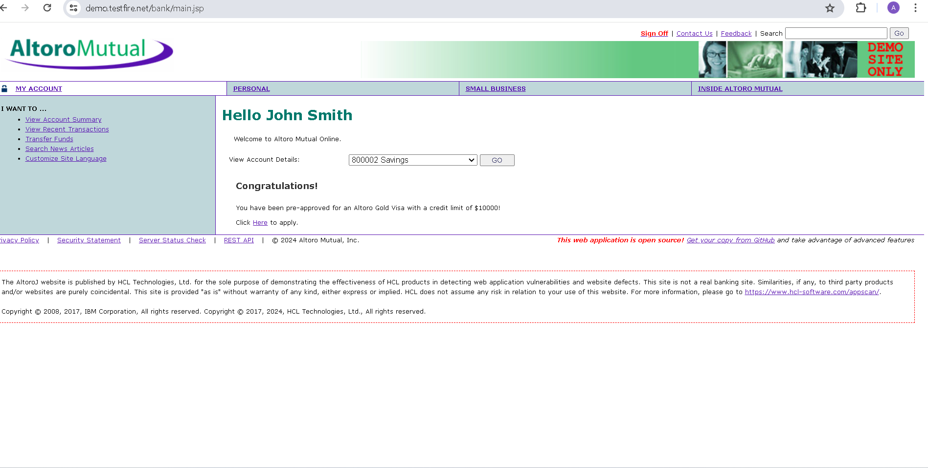

2-Used Burp Suite to intercept the request

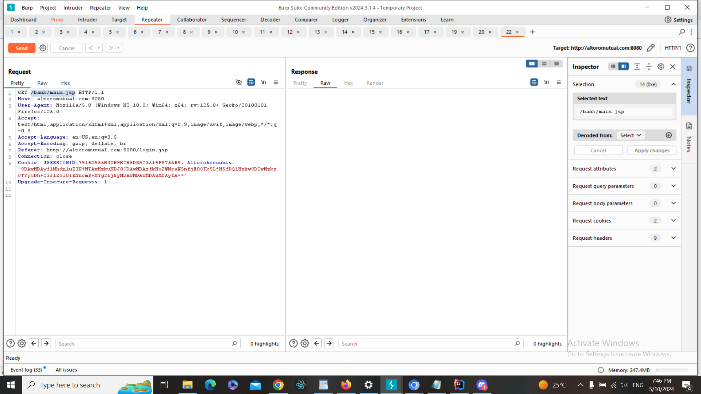

3-Add the following payload remove /bank/main.jsp and replace it with /admin/admin.jsp

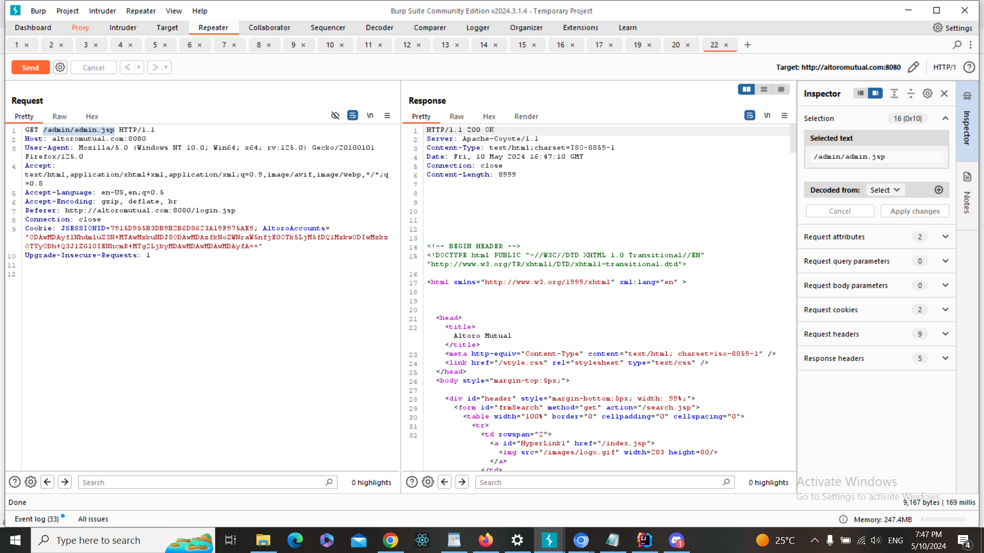

4-The admin page was successfully accessed without proper authorization , and therefore, there is Direct access to admin pages vuln here

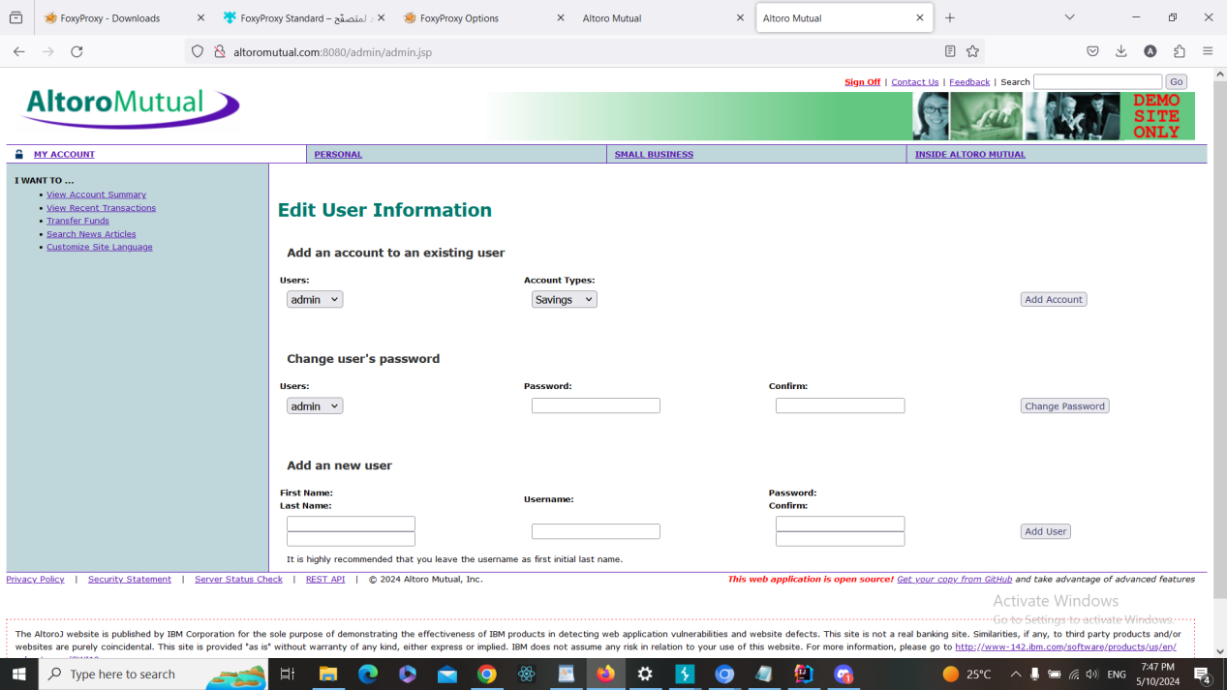

**b. Fixing Steps**

ID14

1- I spot the input in the code

2- I made input validation and/or output encoding as following

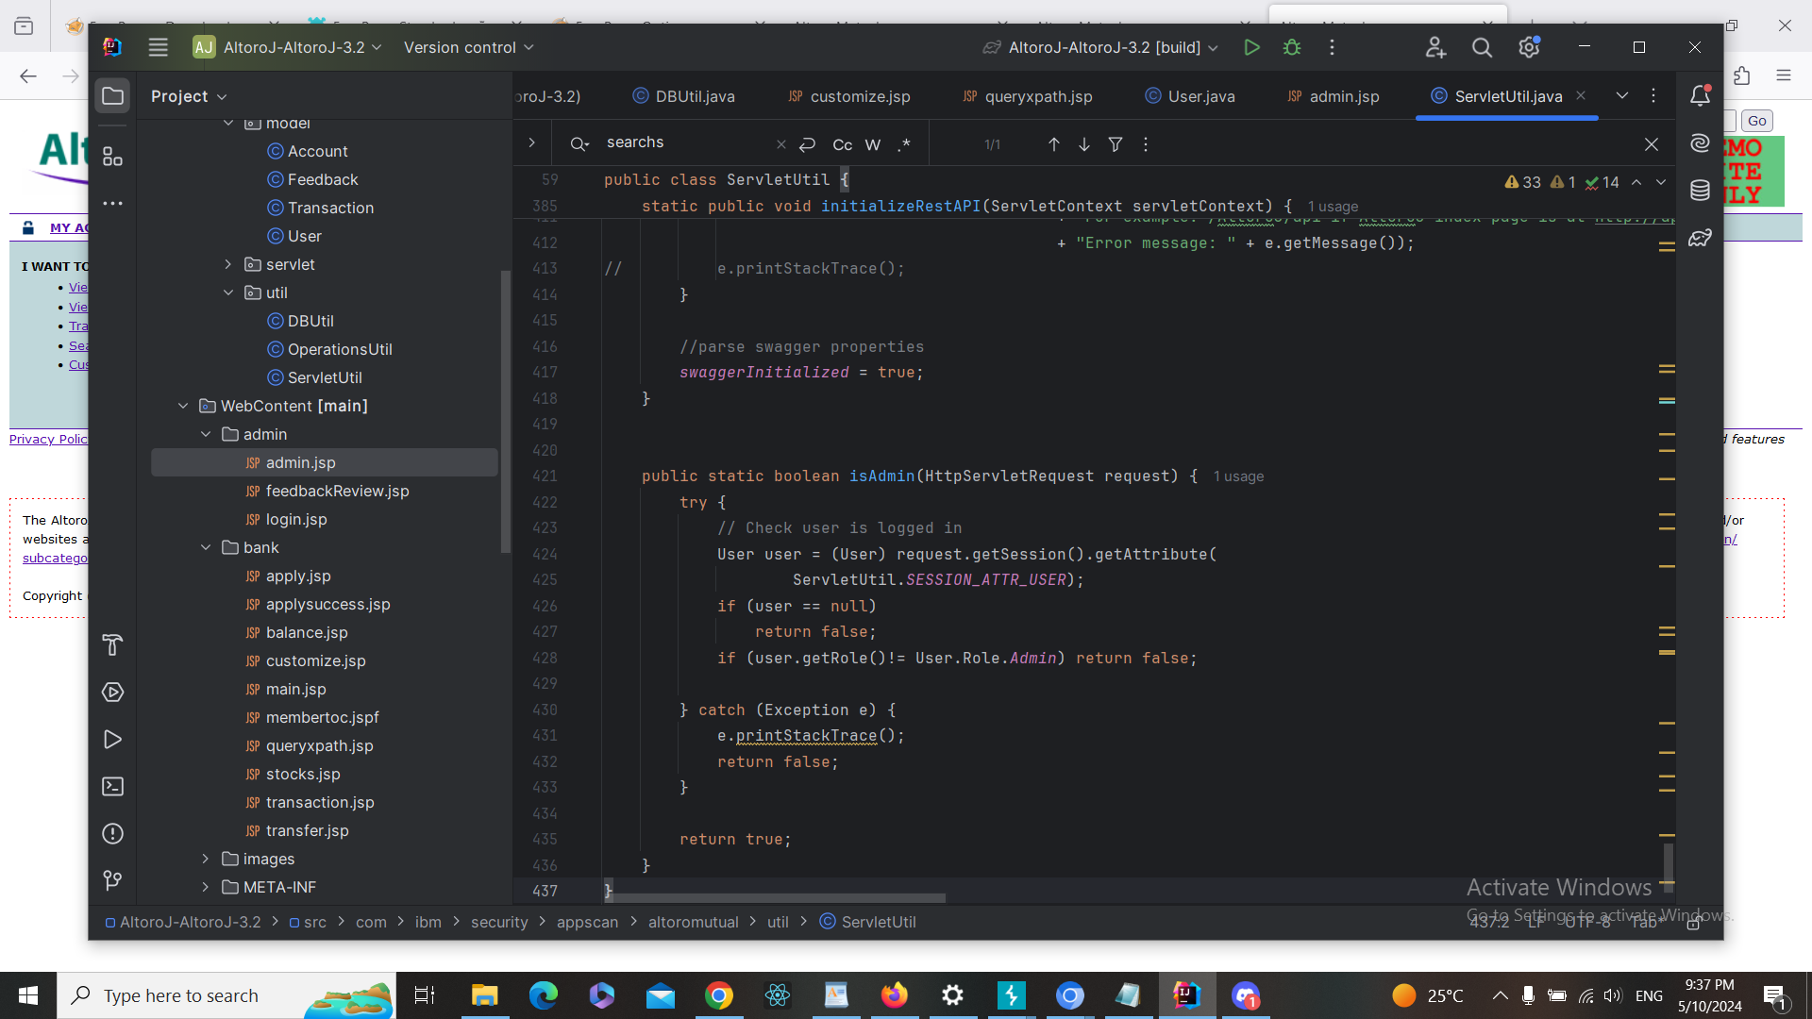

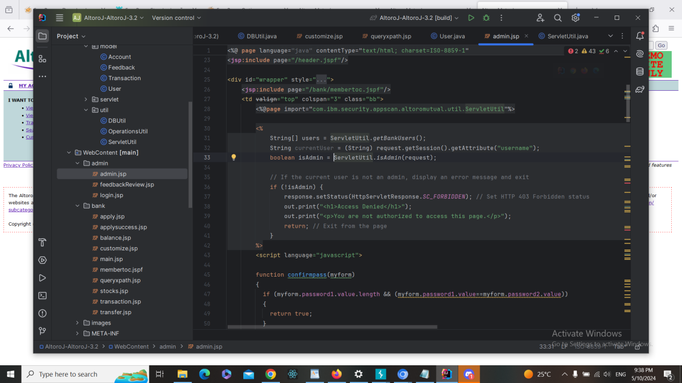

**c. Finding RE-Test Steps:**

ID14

1-Open the following page <https://demo.testfire.net/bank/main.jsp>

and log in with any user credentials



2-Used Burp Suite to intercept the request



3-Add the following payload remove /bank/main.jsp and replace it with /admin/admin.jsp



4- The script has NOT run, and therefore, there is NO XSS vuln here. And the issue

is fixed + screenshot

**Finding details**

**Name: ID15: Information Disclosure in login page**

Test Severity: Informational

Test Score: 0.0

Retest Severity: Resolved

Description:

The login page on the website (https://demo.testfire.net/login.jsp) contains HTML comments that may disclose sensitive information. These comments could potentially reveal details about the application's configuration or sensitive data, posing a risk of information disclosure.

Impact:

The disclosure of sensitive information through HTML comments could provide valuable insights to attackers, aiding them in formulating targeted attacks or identifying potential vulnerabilities.

It may undermine the confidentiality of sensitive data and compromise the security of the application.

Recommendations:

1- Remove or sanitize any HTML comments containing sensitive information from the login page to prevent inadvertent disclosure.

2- Regularly review the HTML source code of web pages for any instances of sensitive information being exposed through comments or other means.

3- Implement secure coding practices to avoid embedding sensitive information in HTML comments or other non-secure areas of the application.

4- Educate developers about the importance of safeguarding sensitive information and the risks associated with information disclosure vulnerabilities.

**Finding scenarios**

**a. Finding Test Steps:**

ID15

1. Open the following page <https://demo.testfire.net/login.jsp>



2-Used Burp Suite to intercept the request

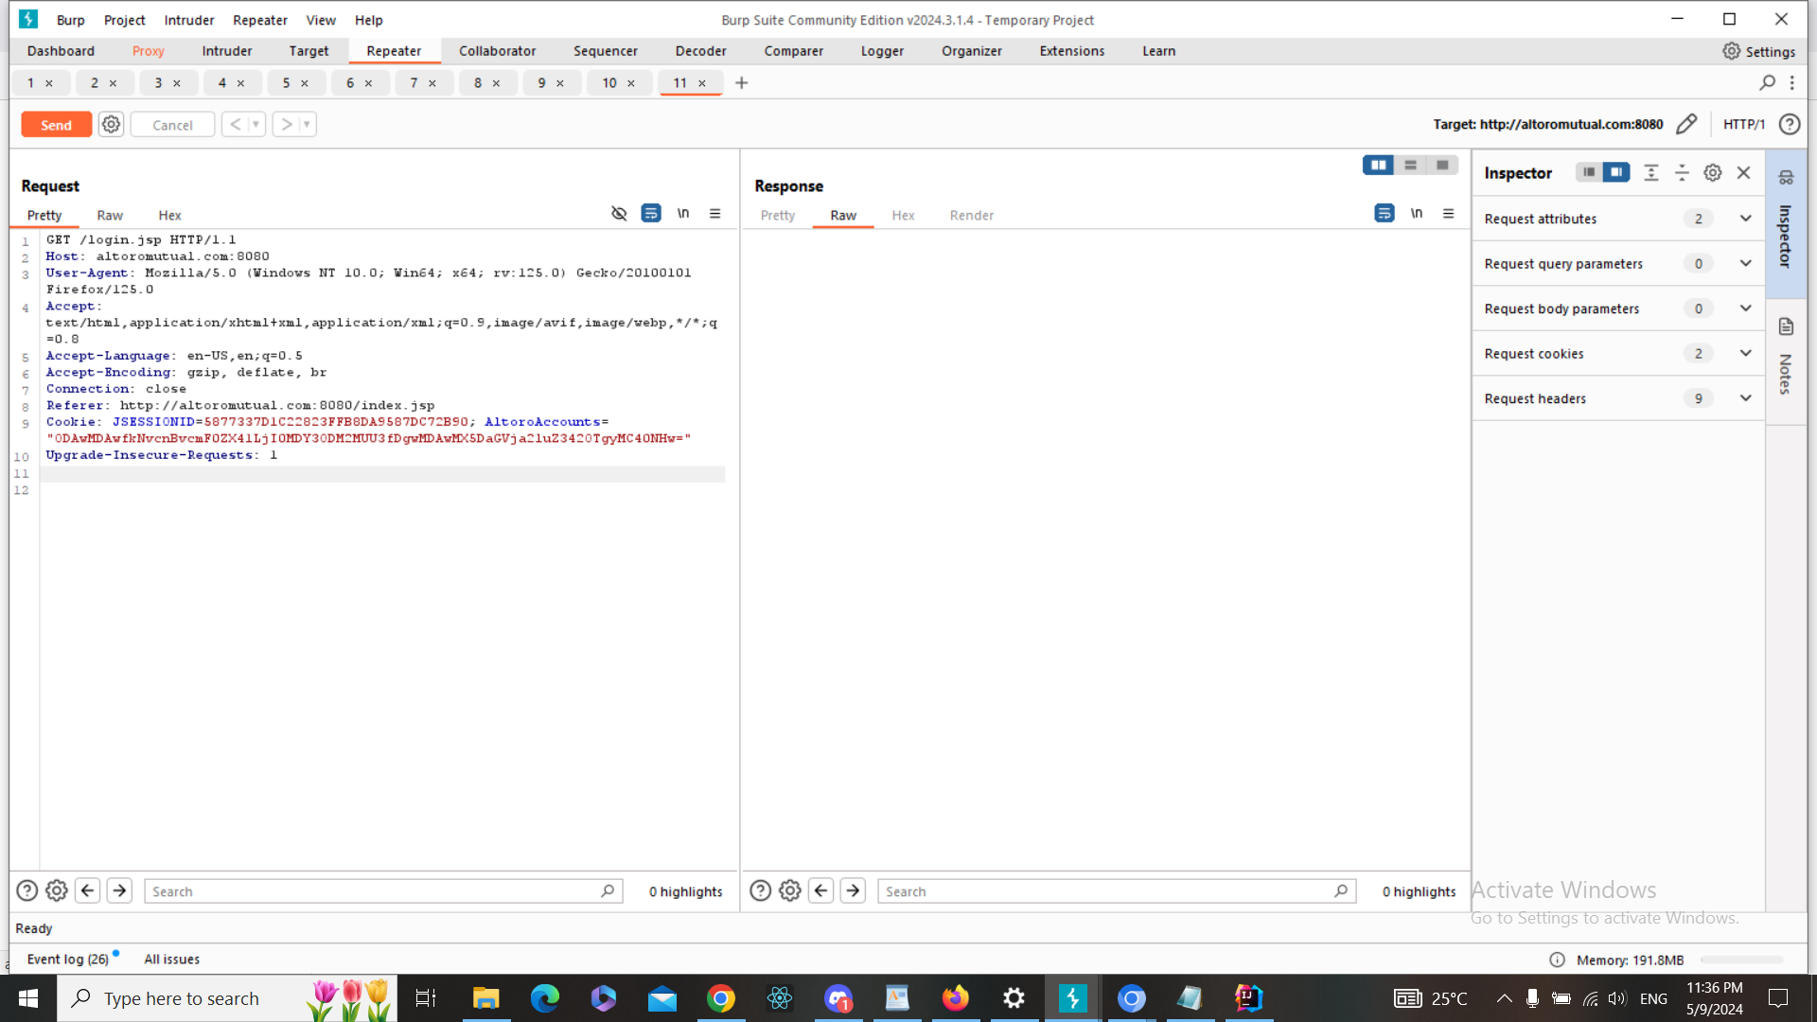

3-Add the following payload no payloads were added remains at it is

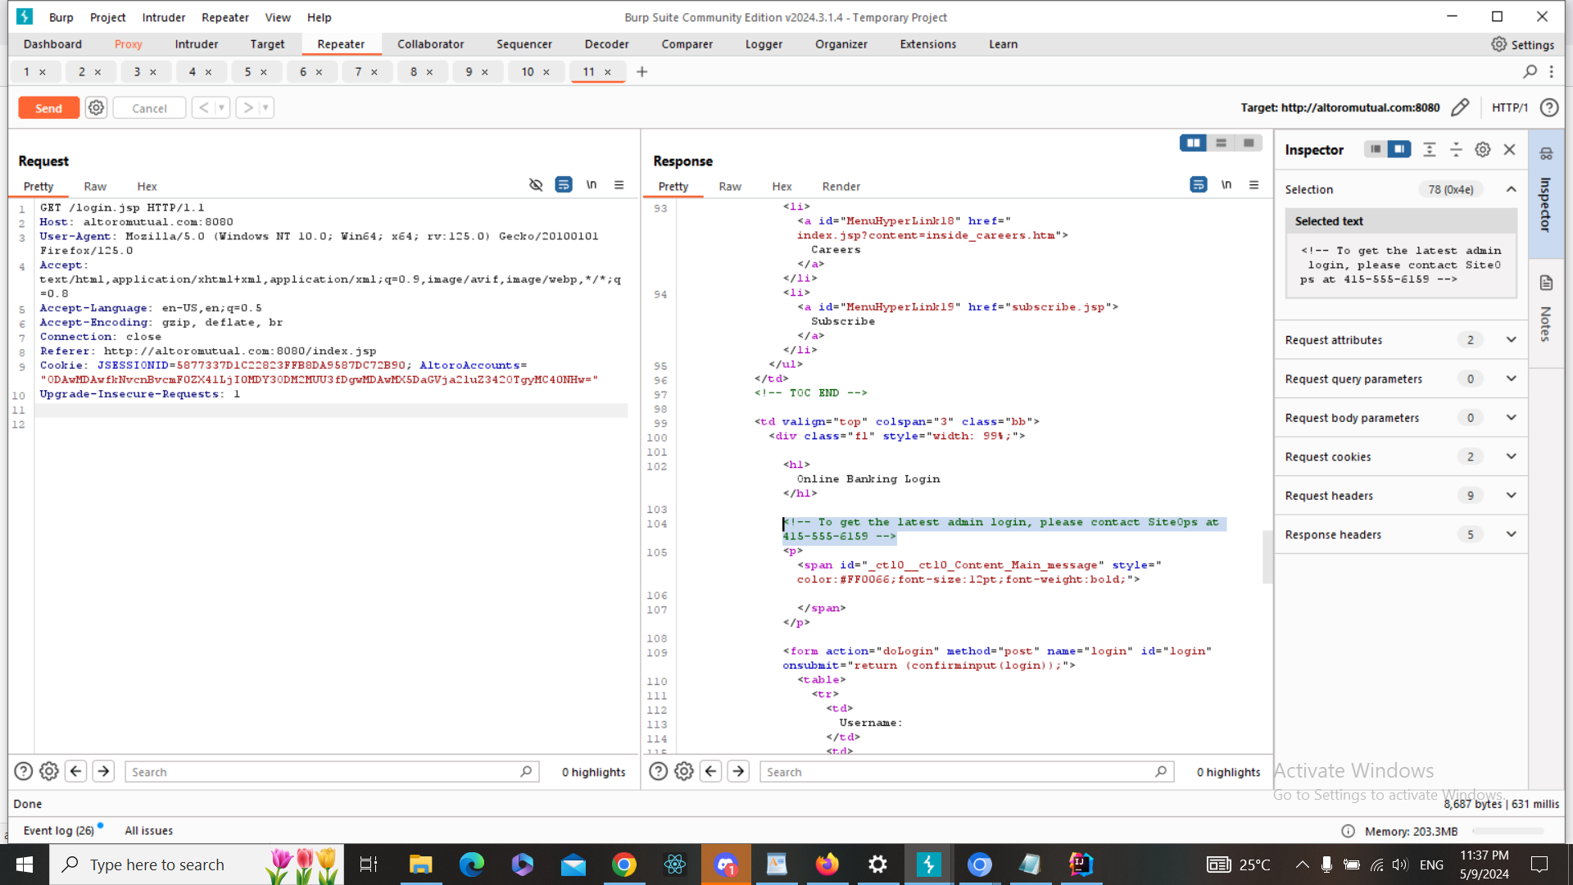

4-The vulnerability was identified through HTML comments containing sensitive information, confirming the presence of the vulnerability (highlighted)



**b. Fixing Steps**

ID15

1- I spot the commentin the code and I removed it

**c. Finding RE-Test Steps:**

ID15

1-Open the following page <https://demo.testfire.net/login.jsp>



2-Used Burp Suite to intercept the request



3-Add the following payload no payloads were added remains at it is

4- The script has NOT run, and therefore, there is NO XSS vuln here. And the issue

is fixed + screenshot

**Finding details**

**Name: ID16: Cross-Site Script in Search New Article**

Test Severity: High

Test Score: 7.3

Retest Severity: Resolved

Description:

The "Search New Article" feature on the website   
(https://demo.testfire.net/search.jsp) is vulnerable to cross-site scripting (XSS) attacks. This vulnerability allows attackers to inject malicious scripts into the application, which may be executed within the context of other users' browsers.

Impact:

Attackers can exploit this vulnerability to steal sensitive user data, such as session cookies, credentials, or personal information.

They can also manipulate the appearance or functionality of the web page, potentially leading to phishing attacks or defacement.

The XSS vulnerability can undermine the trustworthiness and integrity of the website among its users.

Recommendations:

Implement input validation and output encoding to sanitize user input and prevent the execution of malicious scripts.

Use security mechanisms such as Content Security Policy (CSP) to mitigate the risk of XSS attacks by restricting the sources from which content can be loaded.

Conduct regular security assessments and code reviews to identify and address XSS vulnerabilities in a timely manner.

Educate developers about secure coding practices, including the importance of validating and sanitizing user input to prevent XSS attacks.

**Finding scenarios**

**a. Finding Test Steps:**

ID16

1-Open the following page <https://demo.testfire.net/bank/queryxpath.jsp>



2-Used Burp Suite to intercept the request

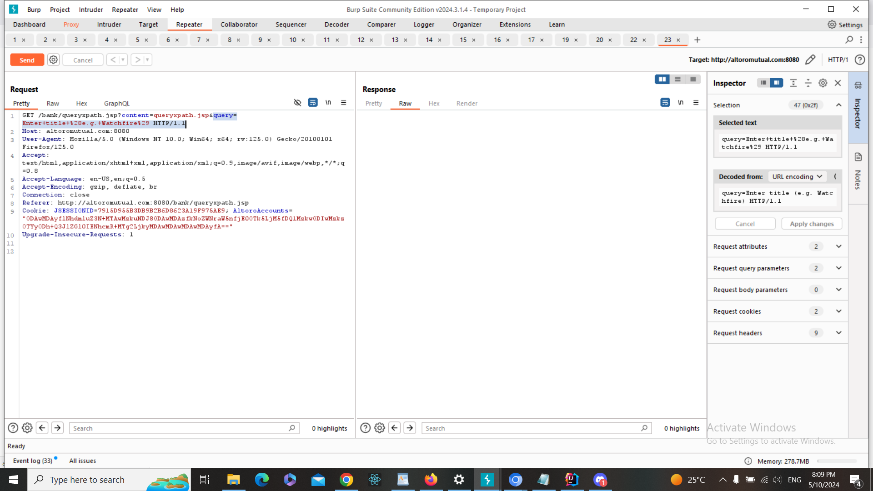

3- Add the following payload

Enter%20title%20(e.g.%20Watchfire)%22%20onMouseOver%3Dalert(%27Hacked%27)%2F%2F%0A

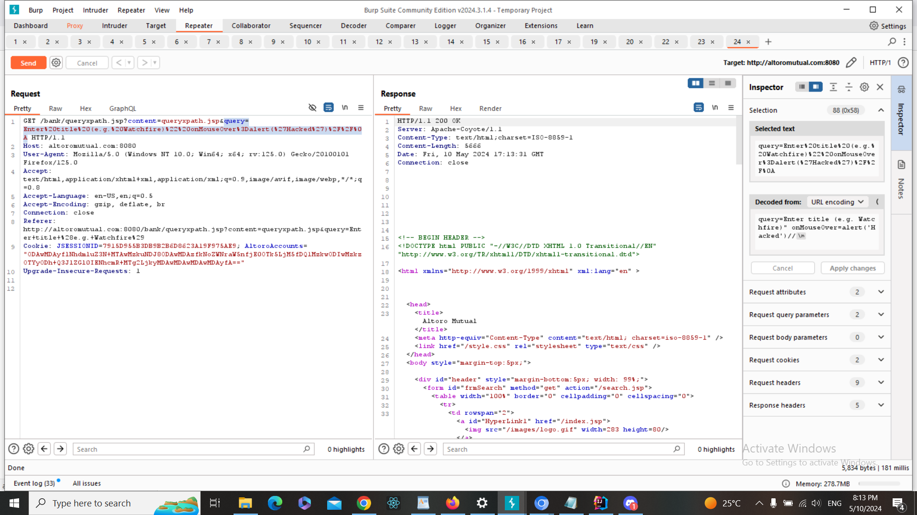

4-The script has run, and therefore, there is XSS vuln here

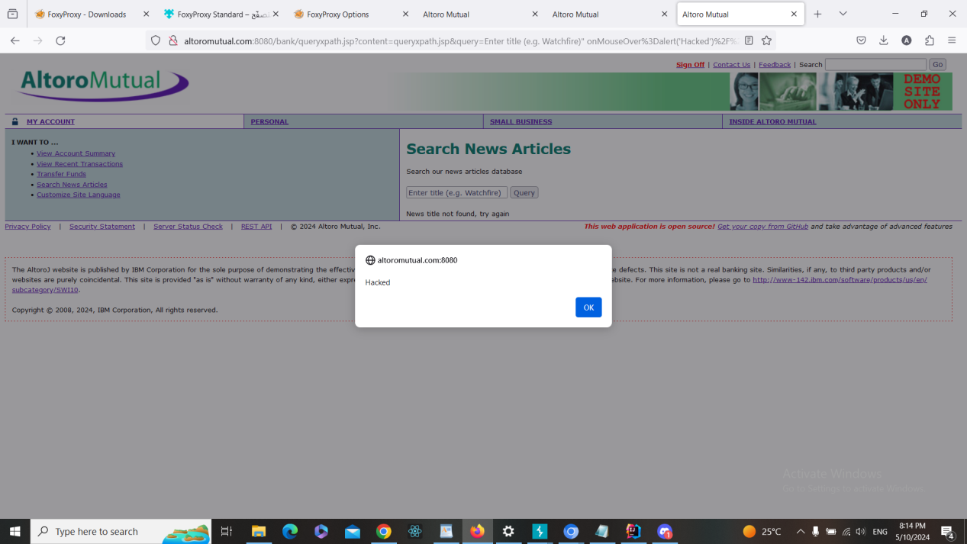

**b. Fixing Steps**

ID16

1- I spot the input in the code

2- I made input validation and/or output encoding as following

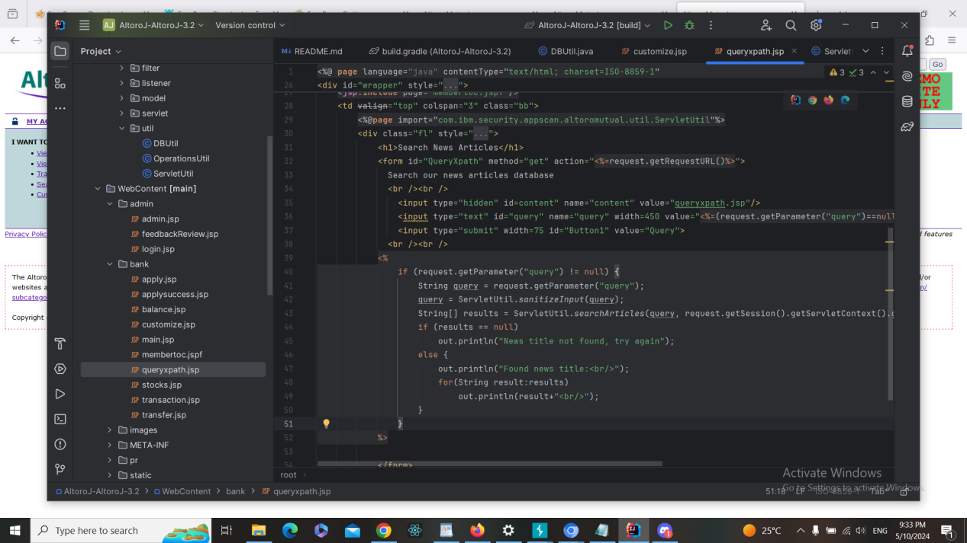

**c. Finding RE-Test Steps:**

ID16

1-Open the following page <https://demo.testfire.net/bank/queryxpath.jsp>



2-Used Burp Suite to intercept the request



3- Add the following payload

Enter%20title%20(e.g.%20Watchfire)%22%20onMouseOver%3Dalert(%27Hacked%27)%2F%2F%0A



4- The script has NOT run, and therefore, there is NO XSS vuln here. And the issue

is fixed + screenshot

**Finding details**

**Name: ID17: Cross-Site Script in Customize Site Language**

Test Severity: High

Test Score: 7.3

Retest Severity: Resolved

Description:

The "Change Site Language" feature on the website   
(https://demo.testfire.net/bank/customize.jsp) is vulnerable to cross-site scripting (XSS) attacks. This vulnerability allows attackers to inject malicious scripts into the application, which may be executed within the context of other users' browsers.

Impact:

Attackers can exploit this vulnerability to steal sensitive user data, such as session cookies, credentials, or personal information.

They can also manipulate the appearance or functionality of the web page, potentially leading to phishing attacks or defacement.

The XSS vulnerability can undermine the trustworthiness and integrity of the website among its users.

Recommendations:

Implement input validation and output encoding to sanitize user input and prevent the execution of malicious scripts.

Use security mechanisms such as Content Security Policy (CSP) to mitigate the risk of XSS attacks by restricting the sources from which content can be loaded.

Conduct regular security assessments and code reviews to identify and address XSS vulnerabilities in a timely manner.

Educate developers about secure coding practices, including the importance of validating and sanitizing user input to prevent XSS attacks.

**Finding scenarios**

**a. Finding Test Steps:**

ID17

1-Open the following page https://demo.testfire.net/bank/customize.jsp



2-Used Burp Suite to intercept the request

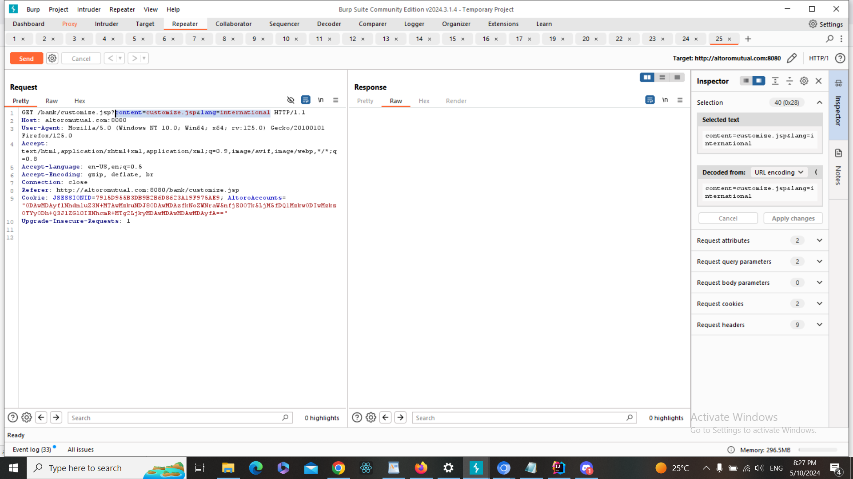

3- Add the following payload

content=%3E%22%27%3E%3Cscript%3Ealert%281050%29%3C%2Fscript%3E&lang=%3E%22%27%3E%3Cscript%3Ealert%281050%29%3C%2Fscript%3E

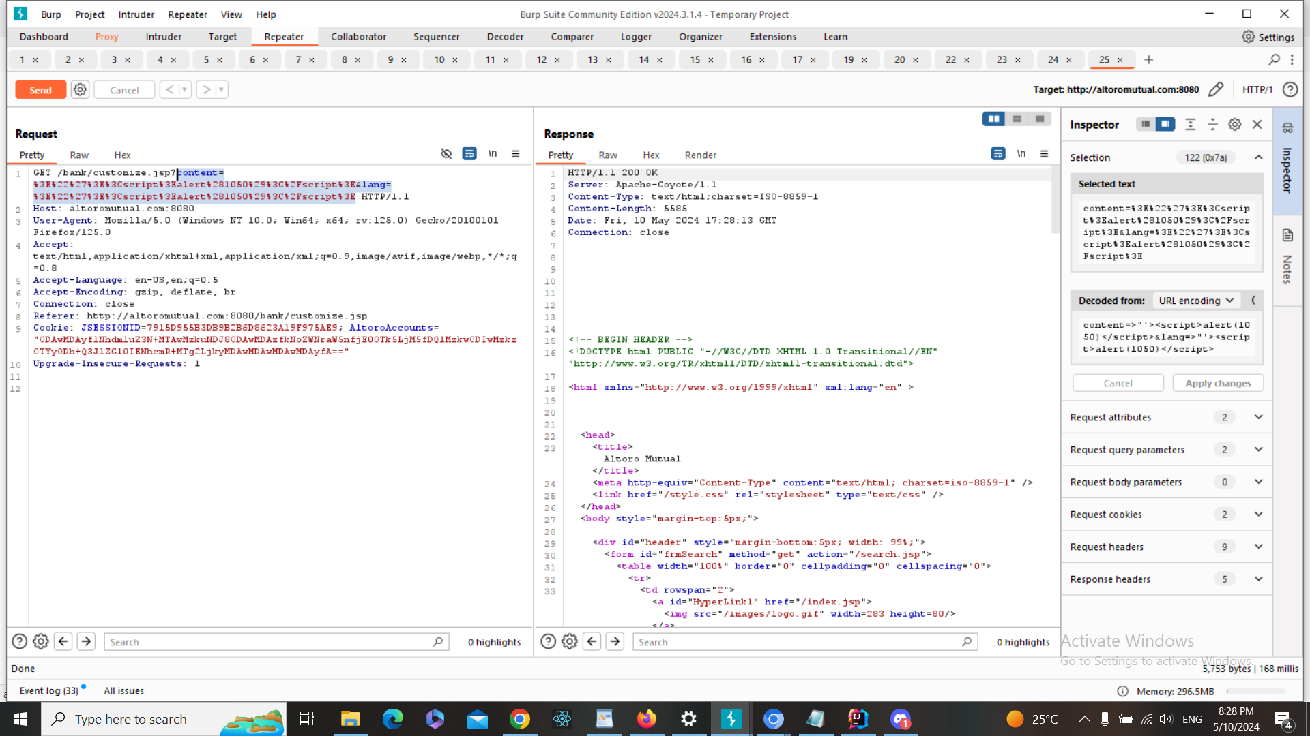

4-The script has run, and therefore, there is XSS vuln here

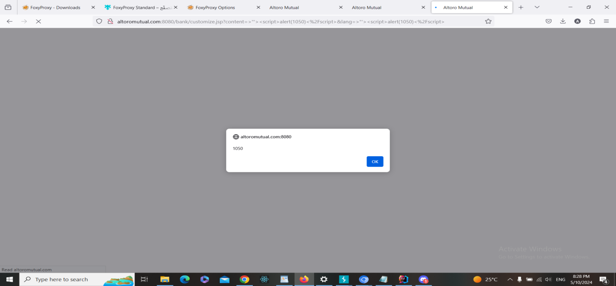

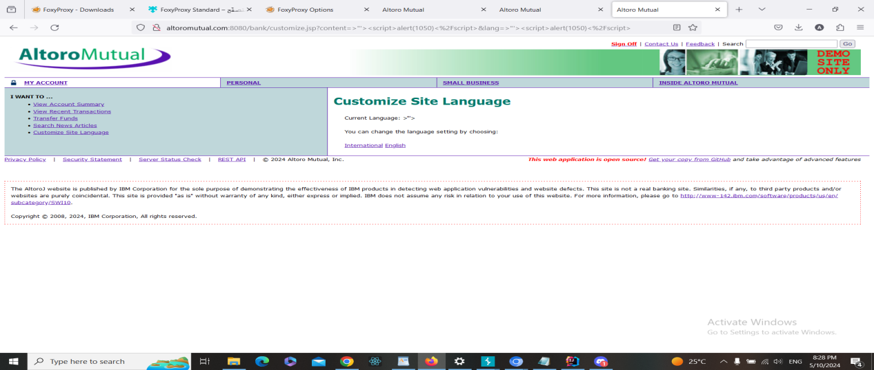

**b. Fixing Steps**

ID17

1- I spot the input in the code

2- I made input validation and/or output encoding as following + screenshot

**c. Finding RE-Test Steps:**

ID17

1-Open the following page https://demo.testfire.net/bank/customize.jsp



2-Used Burp Suite to intercept the request



3- Add the following payload

content=%3E%22%27%3E%3Cscript%3Ealert%281050%29%3C%2Fscript%3E&lang=%3E%22%27%3E%3Cscript%3Ealert%281050%29%3C%2Fscript%3E



4- The script has NOT run, and therefore, there is NO XSS vuln here. And the issue

is fixed + screenshot

**Finding details**

**Name: ID18: Information Disclosure in login page**

Test Severity: Informational

Test Score: 0.0

Retest Severity: Resolved

Description:

The show account page on the website  
(https://demo.testfire.net/bank/main.jsp) contains HTML comments that may disclose sensitive information. These comments could potentially reveal details about the application's configuration or sensitive data, posing a risk of information disclosure.

Impact:

The disclosure of sensitive information through HTML comments could provide valuable insights to attackers, aiding them in formulating targeted attacks or identifying potential vulnerabilities.

It may undermine the confidentiality of sensitive data and compromise the security of the application.

Recommendations:

1- Remove or sanitize any HTML comments containing sensitive information from the login page to prevent inadvertent disclosure.

2- Regularly review the HTML source code of web pages for any instances of sensitive information being exposed through comments or other means.

3- Implement secure coding practices to avoid embedding sensitive information in HTML comments or other non-secure areas of the application.

4- Educate developers about the importance of safeguarding sensitive information and the risks associated with information disclosure vulnerabilities.

**Finding scenarios**

**a. Finding Test Steps:**

ID18

1-Open the following page https://demo.testfire.net/bank/main.jsp



2-Used Burp Suite to intercept the request

No need

3-Add the following payload no payloads were added remains at it is

4-The vulnerability was identified through HTML comments containing sensitive information, confirming the presence of the vulnerability (highlighted)

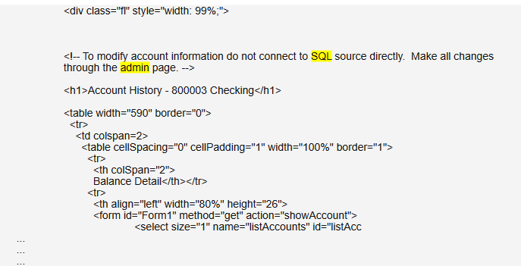

**b. Fixing Steps**

ID18

1- I spot the commented part in the code and removed it

**c. Finding RE-Test Steps:**

ID18

1- Open the following page + screenshot

2- Used Burp Suite to intercept the request + screenshot

3- Added the following payload + screenshot (like the original test)

4- The script has NOT run, and therefore, there is NO XSS vuln here. And the issue

is fixed + screenshot

**Finding details**

**Name: ID19: Information Disclosure in Feedback page**

Test Severity: Informational

Test Score: 0.0

Retest Severity: Resolved

Description:

The feedback page on the   
website (https://demo.testfire.net/feedback.jsp) contains HTML comments that may disclose sensitive information. These comments could potentially reveal details about the application's configuration or sensitive data, posing a risk of information disclosure.

Impact:

The disclosure of sensitive information through HTML comments could provide valuable insights to attackers, aiding them in formulating targeted attacks or identifying potential vulnerabilities.

It may undermine the confidentiality of sensitive data and compromise the security of the application.

Recommendations:

1- Remove or sanitize any HTML comments containing sensitive information from the login page to prevent inadvertent disclosure.

2- Regularly review the HTML source code of web pages for any instances of sensitive information being exposed through comments or other means.

3- Implement secure coding practices to avoid embedding sensitive information in HTML comments or other non-secure areas of the application.

4- Educate developers about the importance of safeguarding sensitive information and the risks associated with information disclosure vulnerabilities.

**Finding scenarios**

**a. Finding Test Steps:**

ID19

1. Open the following page https://demo.testfire.net/feedback.jsp

2-Used Burp Suite to intercept the request (No need)

3-Add the following payload no payloads were added remains at it is

4-The vulnerability was identified through HTML comments containing sensitive information, confirming the presence of the vulnerability (highlighted)

(The response contains the absolute paths and/or filenames of files on the server)

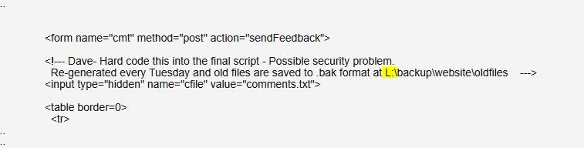

**b. Fixing Steps**

ID19

1- I spot the commented part in the code and removed it

**c. Finding RE-Test Steps:**

ID19

1- Open the following page + screenshot

2- Used Burp Suite to intercept the request + screenshot

3- Added the following payload + screenshot (like the original test)

4- The script has NOT run, and therefore, there is NO XSS vuln here. And the issue

is fixed + screenshot

Name: ID020: Integer Overflow at account main (Show Account)

Test Severity: High

Test Score: Resolved

Description:

The account main page, specifically the Show Account functionality, was susceptible to an integer overflow vulnerability. This issue could have potentially allowed attackers to manipulate integer values, leading to unexpected behavior or system crashes.

Impact:

If exploited, this vulnerability could have resulted in system instability, denial of service, or potential security breaches.

Recommendations:

Perform thorough input validation and boundary checks to prevent integer overflow vulnerabilities.

Regularly update and patch the software to address known vulnerabilities and mitigate risks.

Name: ID020: Integer Overflow at account main (Show Account)

Test Severity: High

Test Score: 8.6

Retest Severity: Resolved

Description:

The account main page, specifically the Show Account functionality, was susceptible to an integer overflow vulnerability. This issue could have potentially allowed attackers to manipulate integer values, leading to unexpected behavior or system crashes.

Impact:

If exploited, this vulnerability could have resulted in system instability, denial of service, or potential security breaches.

Recommendations:

Perform thorough input validation and boundary checks to prevent integer overflow vulnerabilities.

Regularly update and patch the software to address known vulnerabilities and mitigate risks.

Name: ID021: Integer Overflow in Money Transfer

Test Severity: High

Test Score: 8.6

Retest Severity: Resolved

Description:

The Money Transfer functionality was prone to an integer overflow vulnerability. This vulnerability could have allowed malicious users to manipulate integer values during money transfer operations, potentially leading to financial loss or system malfunction.

Impact:

Exploitation of this vulnerability could have resulted in unauthorized money transfers, financial discrepancies, or system crashes.

Recommendations:

Implement strict input validation and data sanitization techniques to prevent integer overflow vulnerabilities.

Conduct regular security audits and code reviews to identify and mitigate potential security risks.

Keep the software and libraries up to date with the latest security patches to minimize exposure to known vulnerabilitie

screenshots after fixes

